**Task 3**

**Testing The Website and Writing the Report**

**Annual Charity Show (ACS)** website is a pet charity website. ACS collects donation for pets to support them. ACS website has 8 pages.

1. **index.html** for **Home Page**
2. **chr_ents.html** for **Charity Events**
3. **fund_raising.html** for **Fund Raising**
4. **community.html** for **Community**
5. **news_review.html** for **News & Reviews**
6. **tls_calc.html** for **Tools and Calculators**
7. **Joinus.html** for **Join Us Now**
8. **Signin.html**

Here all the pages of the website had been validated by using w3c validation service and screenshots were taken as proof of work which are also provided here.

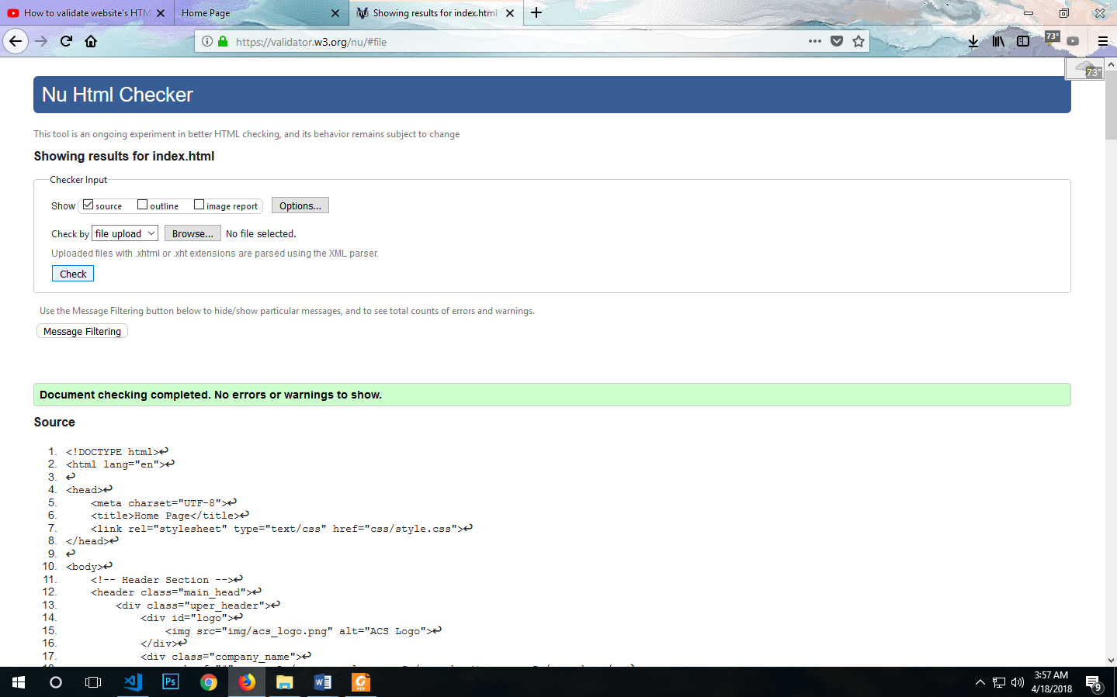

Page 1: Home Page

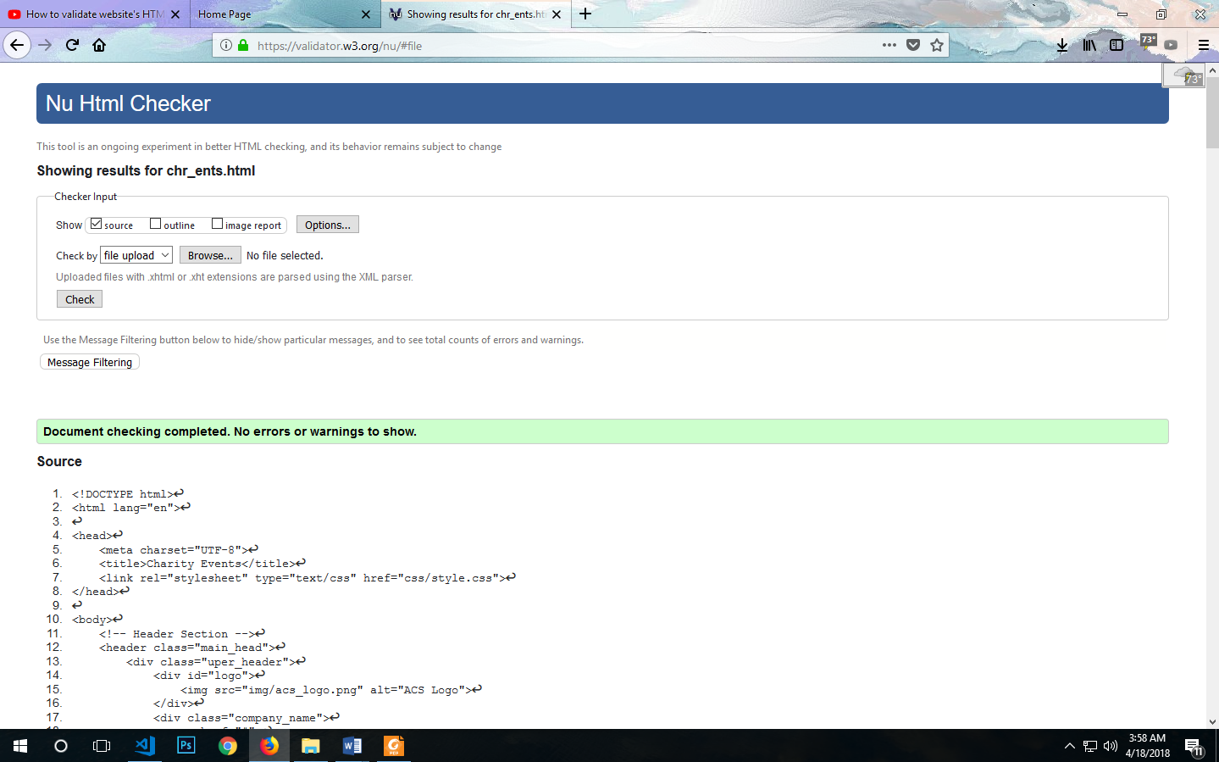

Page 2:Charity Events

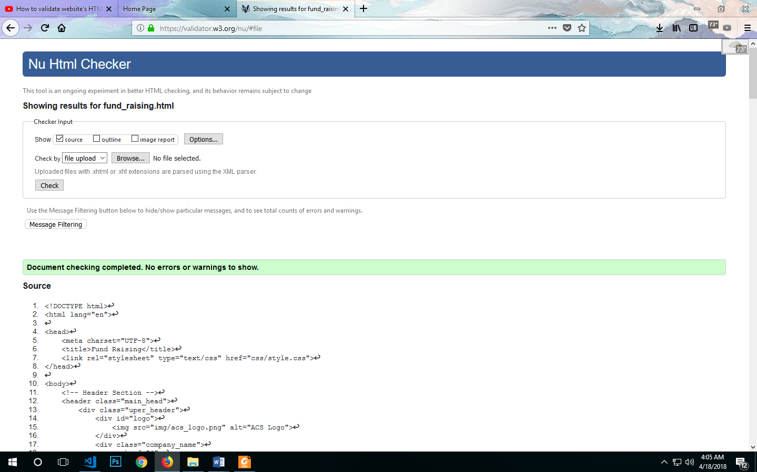

Page 3:Charity Events

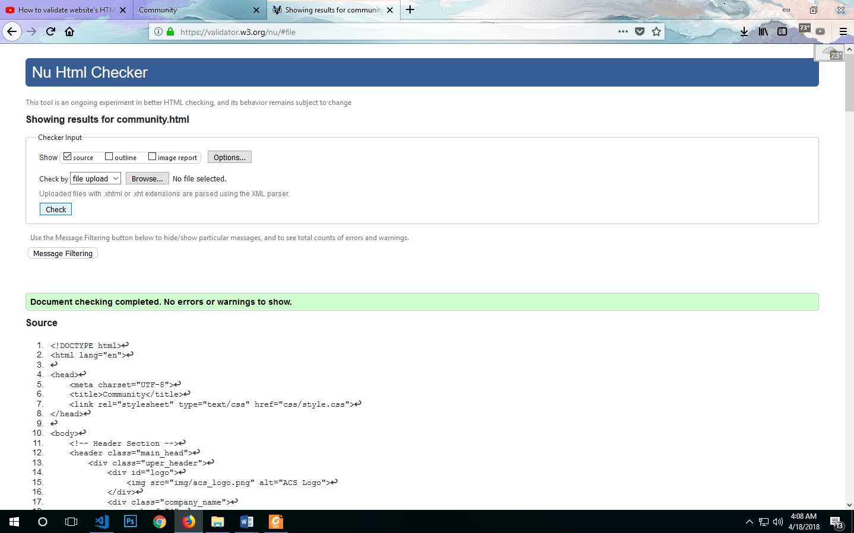

Page 4:Community

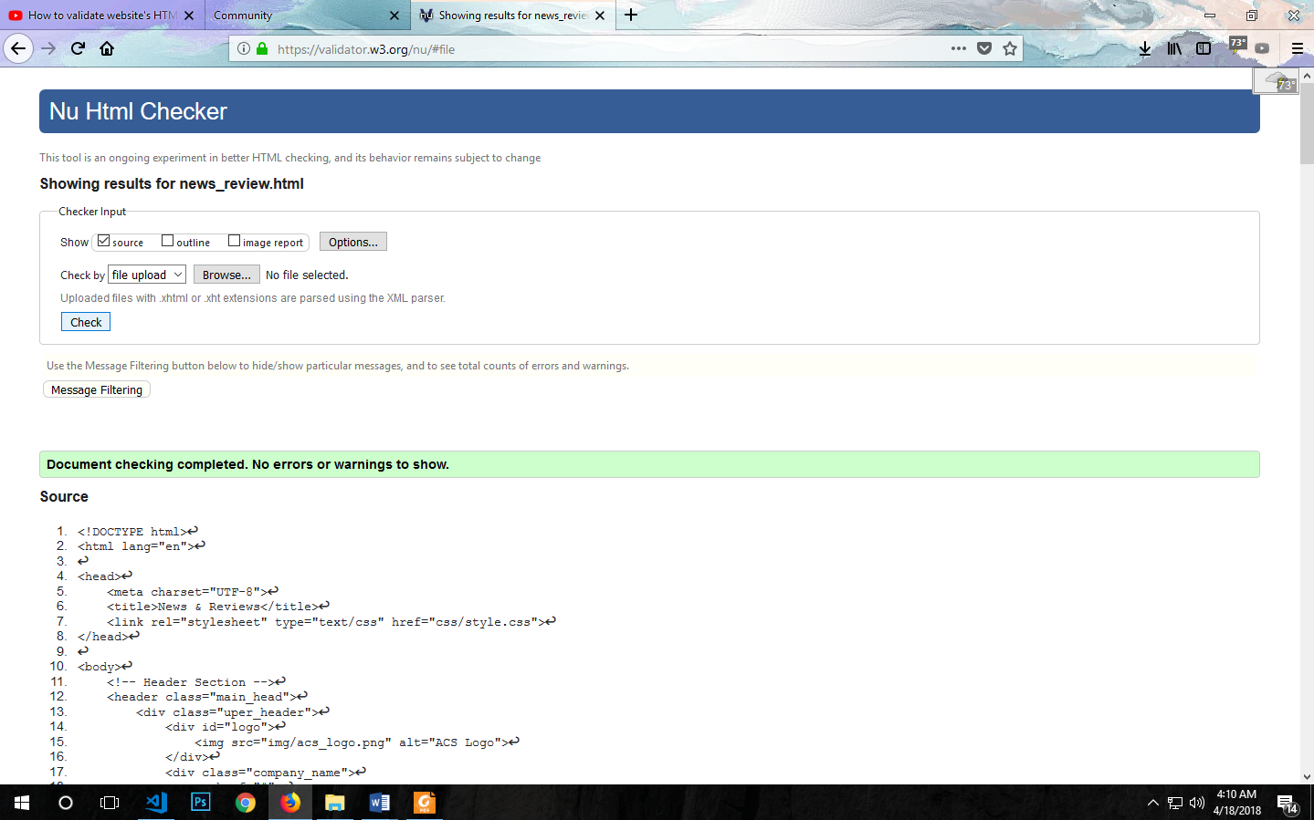

Page 5: News & Reviews

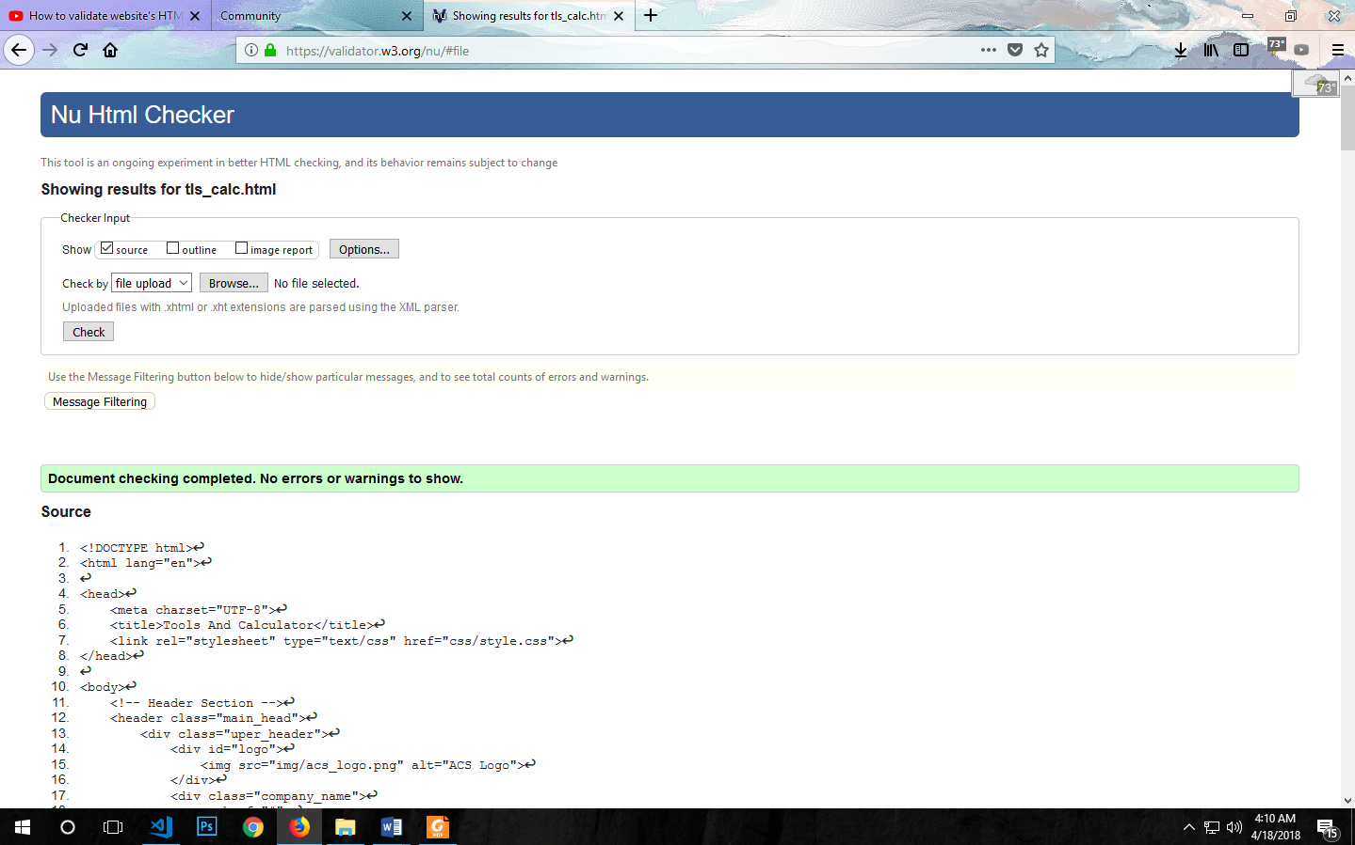

Page 6: Tools and Calculators

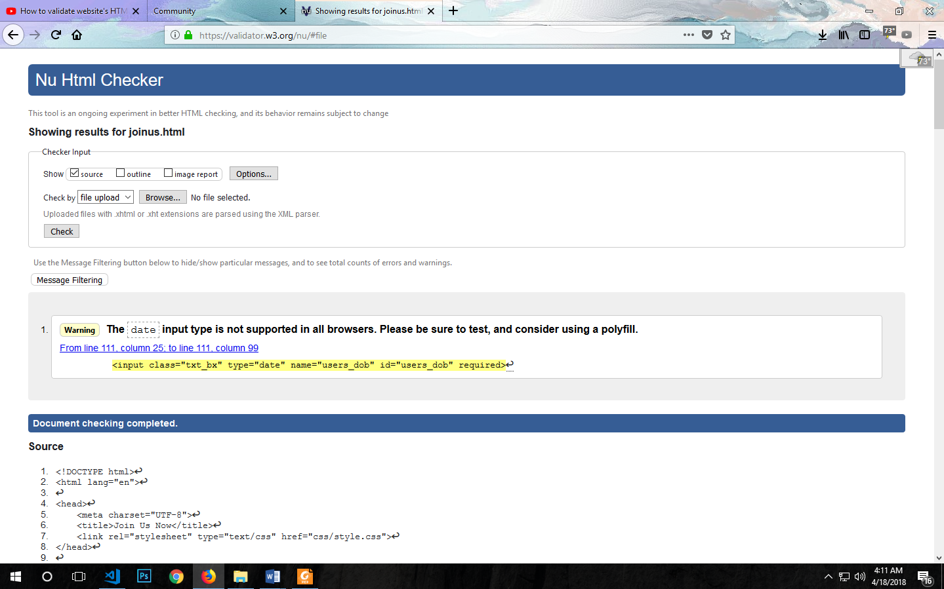

Page 7: Join Us Now

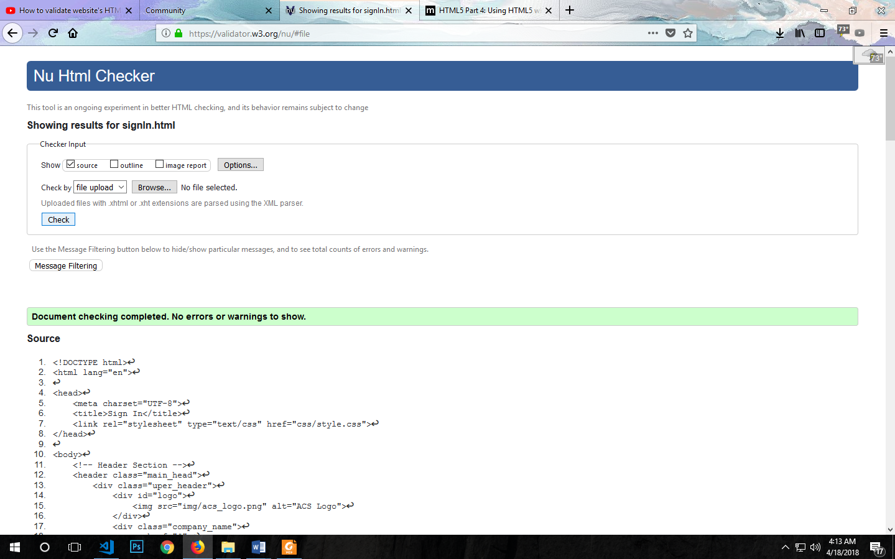

Page 8: Sign In

**CSS validation:**

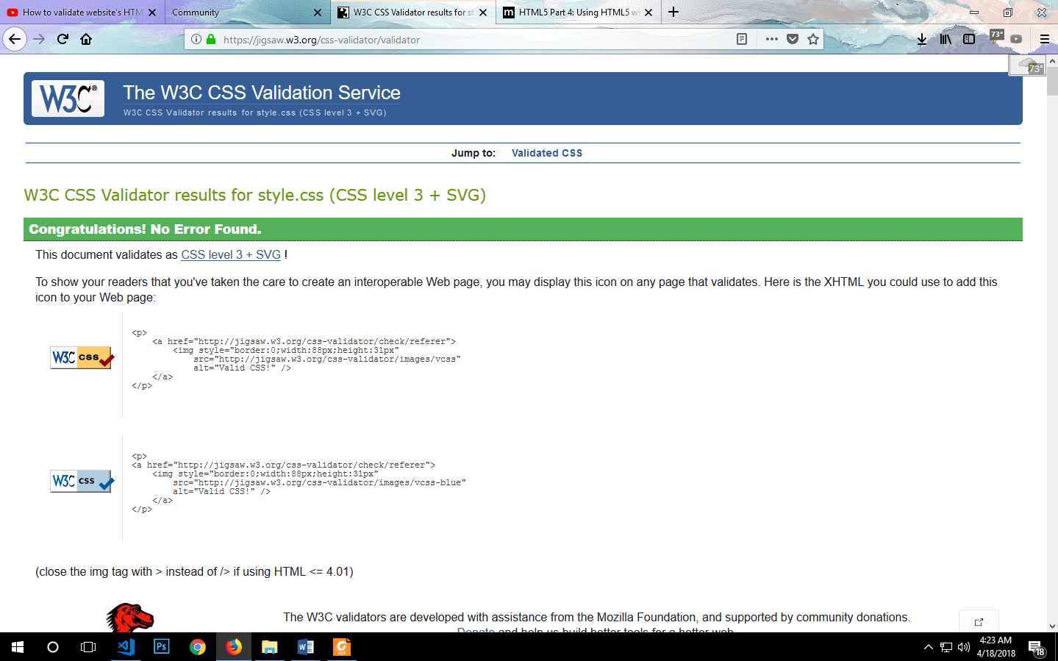

Page 9: CSS File Validation

**Mobile view validation:**

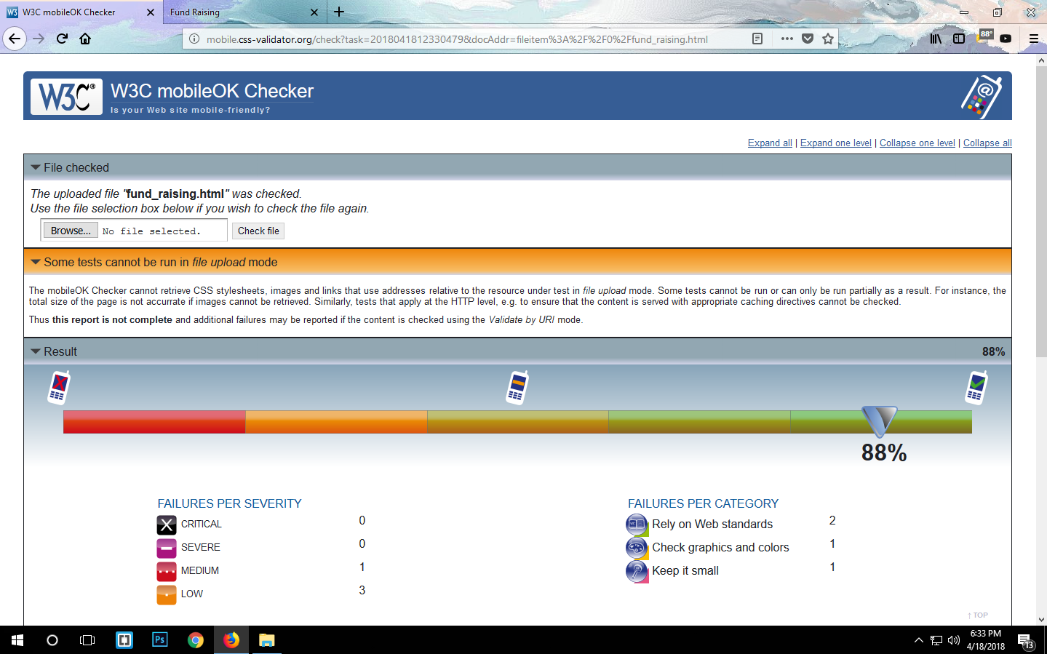

Page 10:Fund Raising Mobile Validation Check

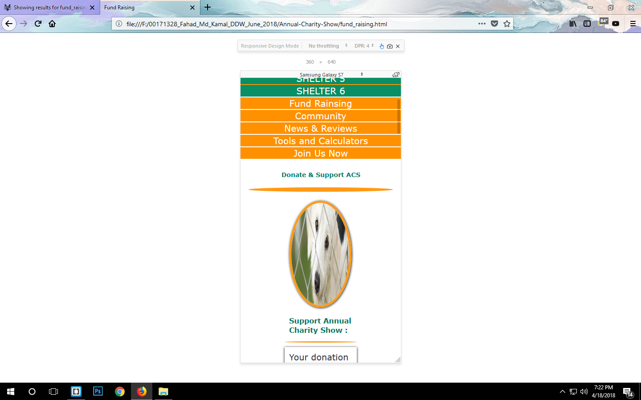

Page 11: Mobile View of Fund Raising Page

**Test of the web page in Two Different Browser (Mozilla Firefox & Google Chrome):**

**Home Page**:

Firefox view:

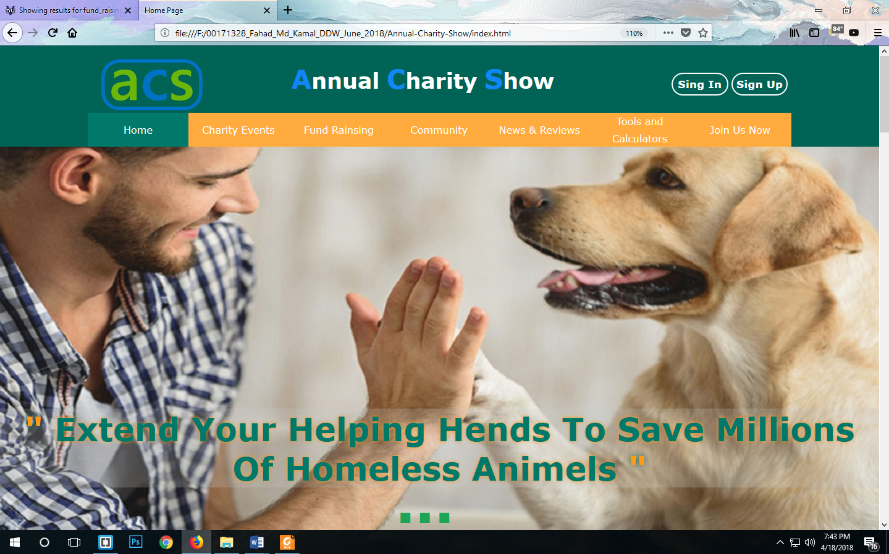

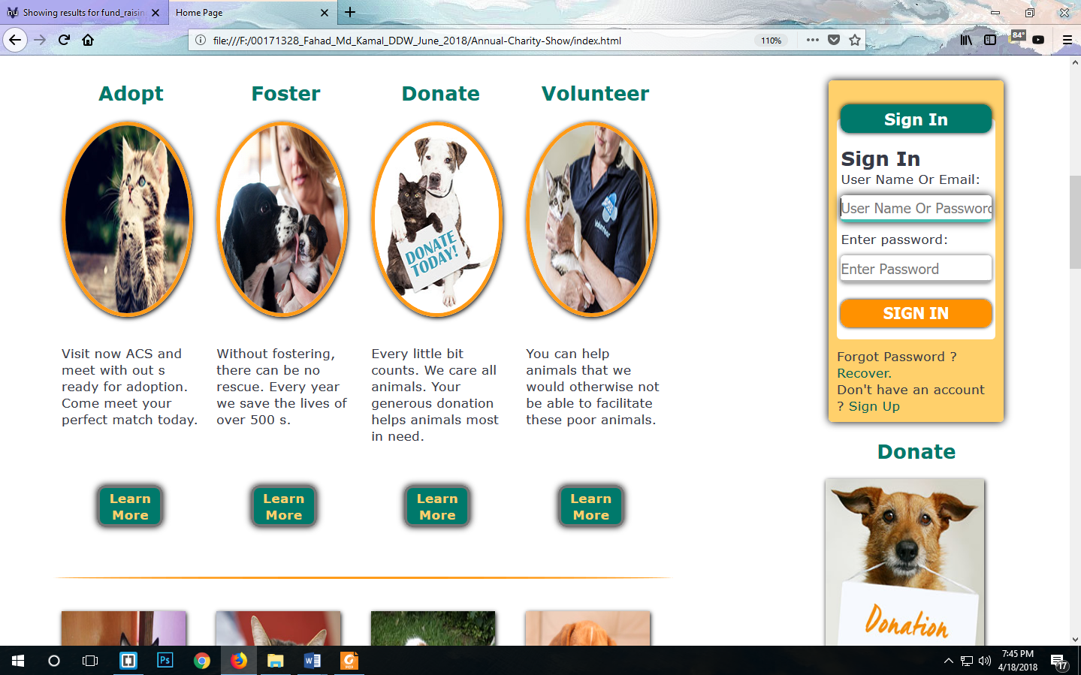

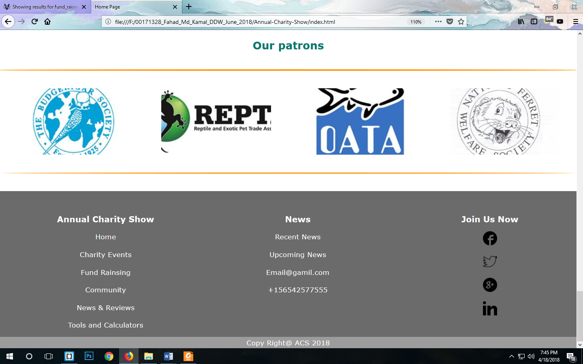

**Chrome View:**

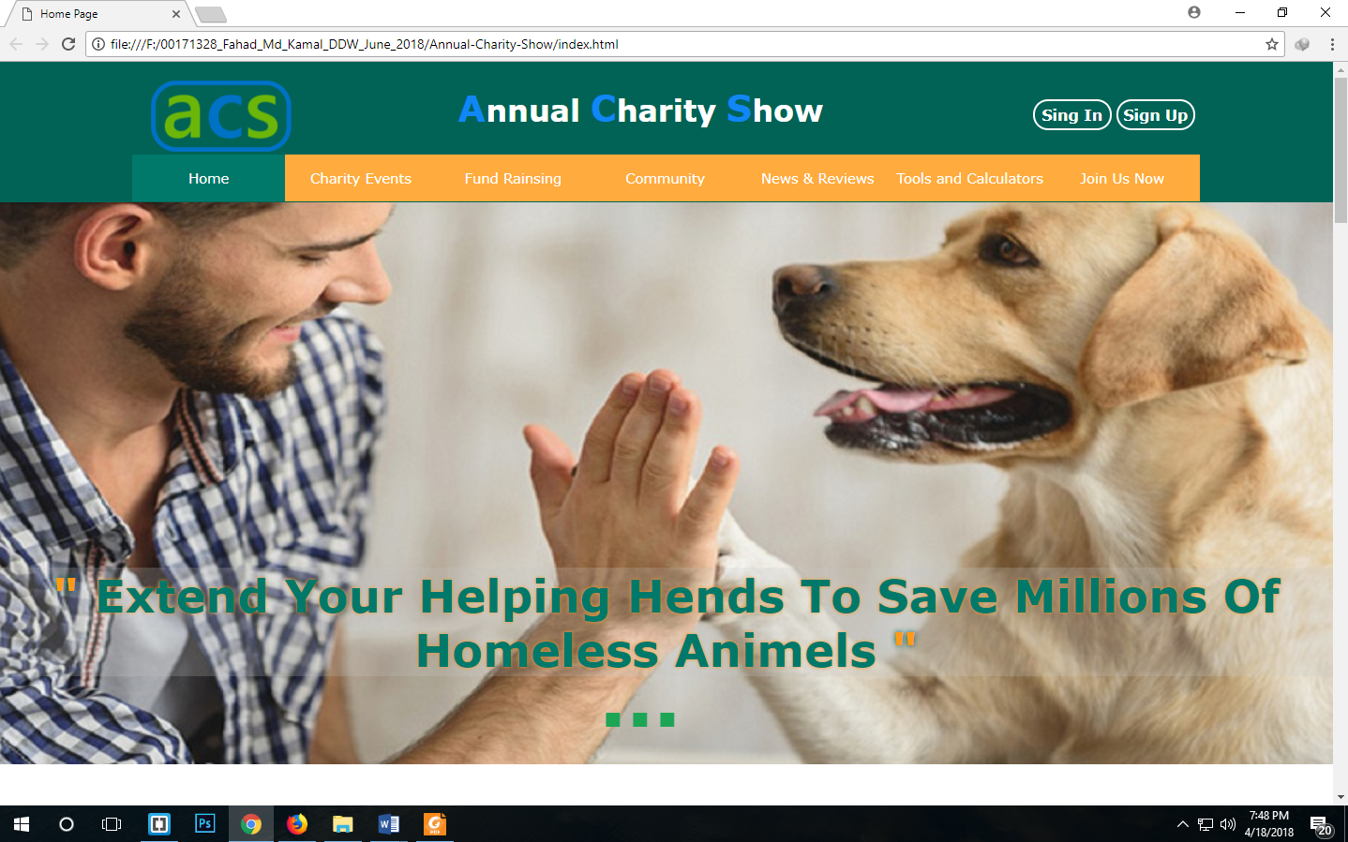

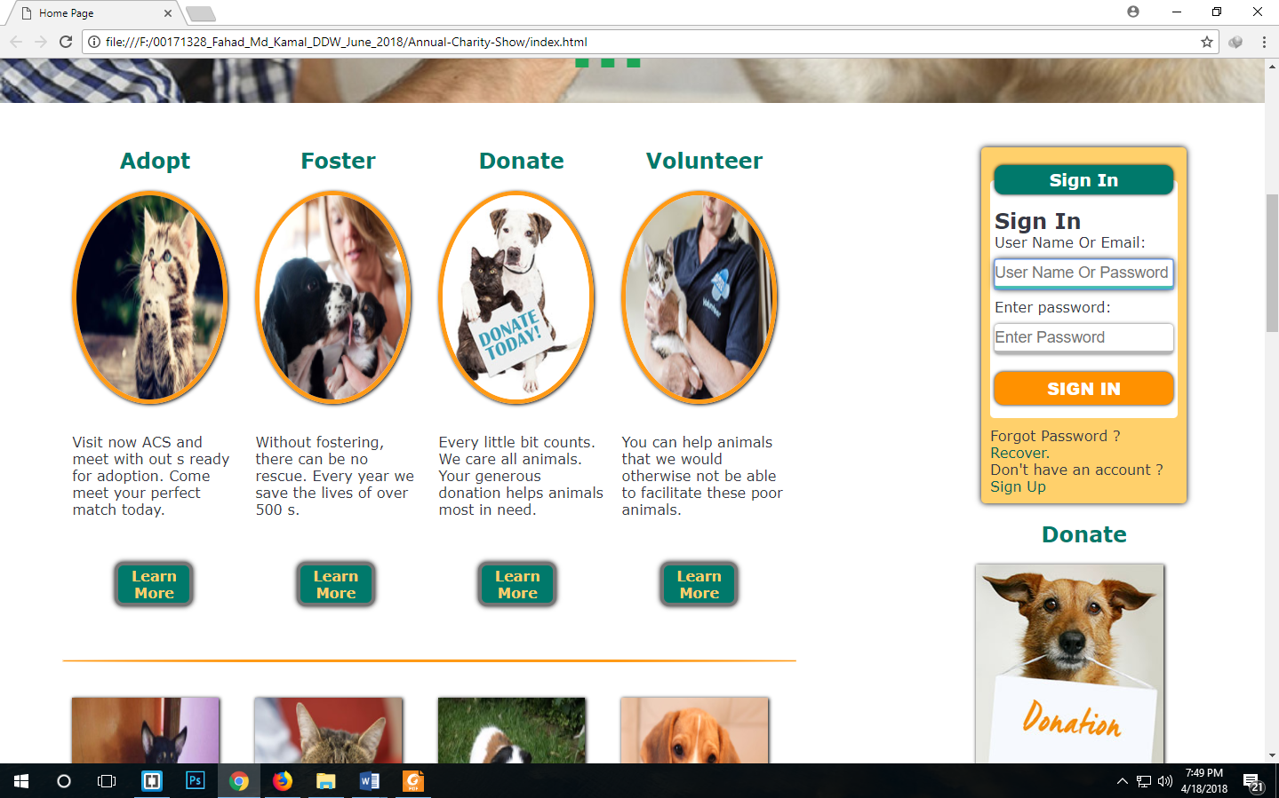

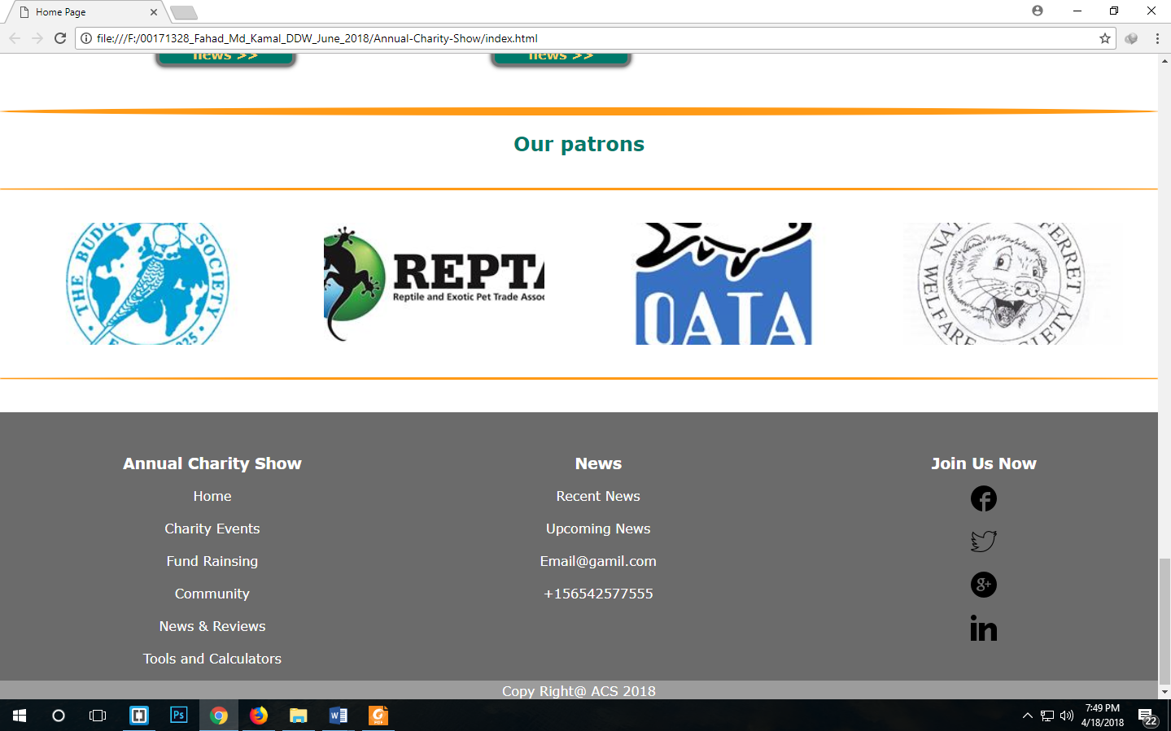

**Charity Events Page:**

**Mozilla View:**

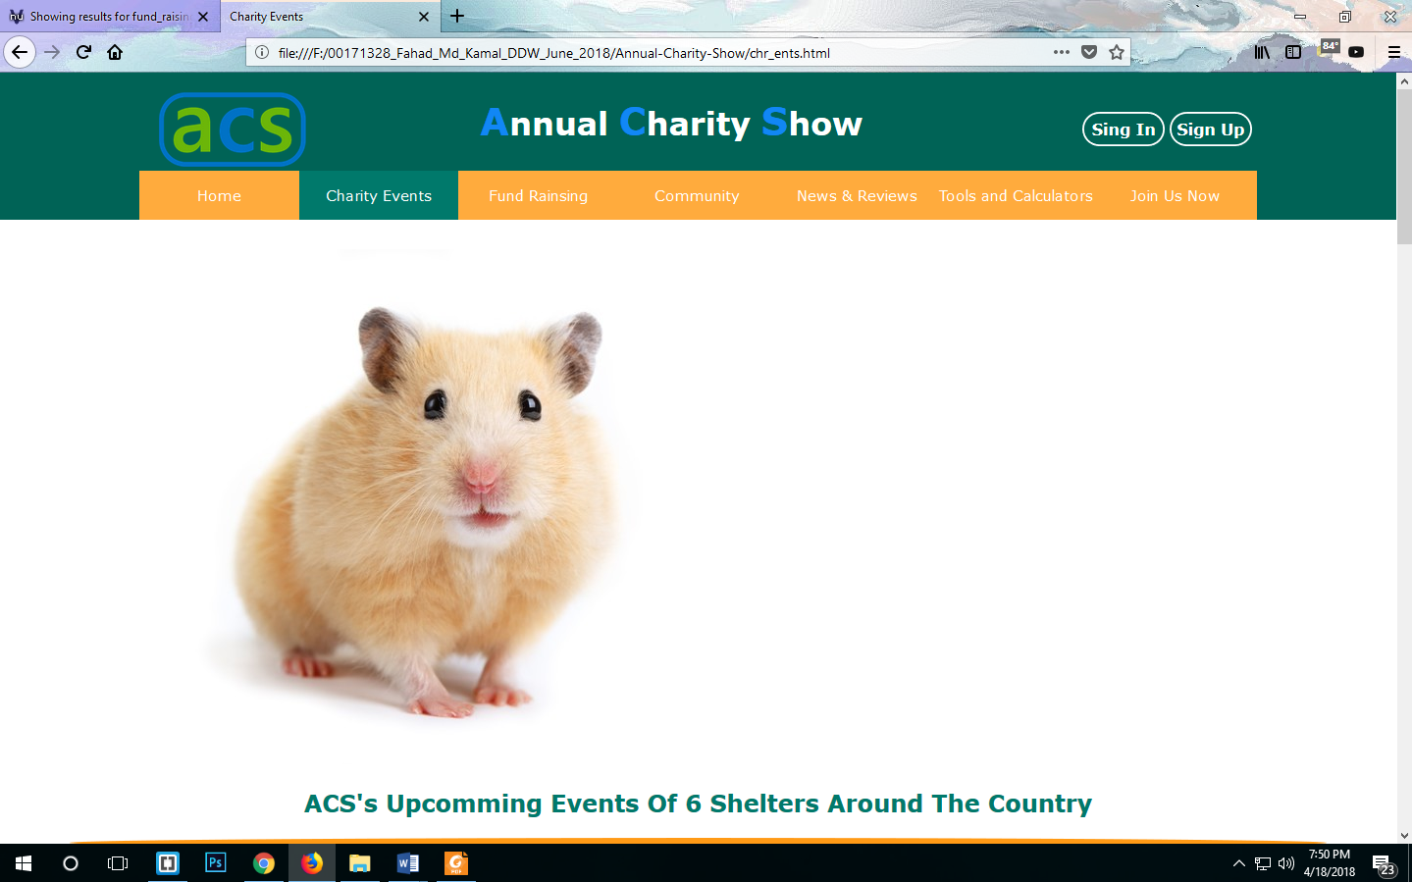

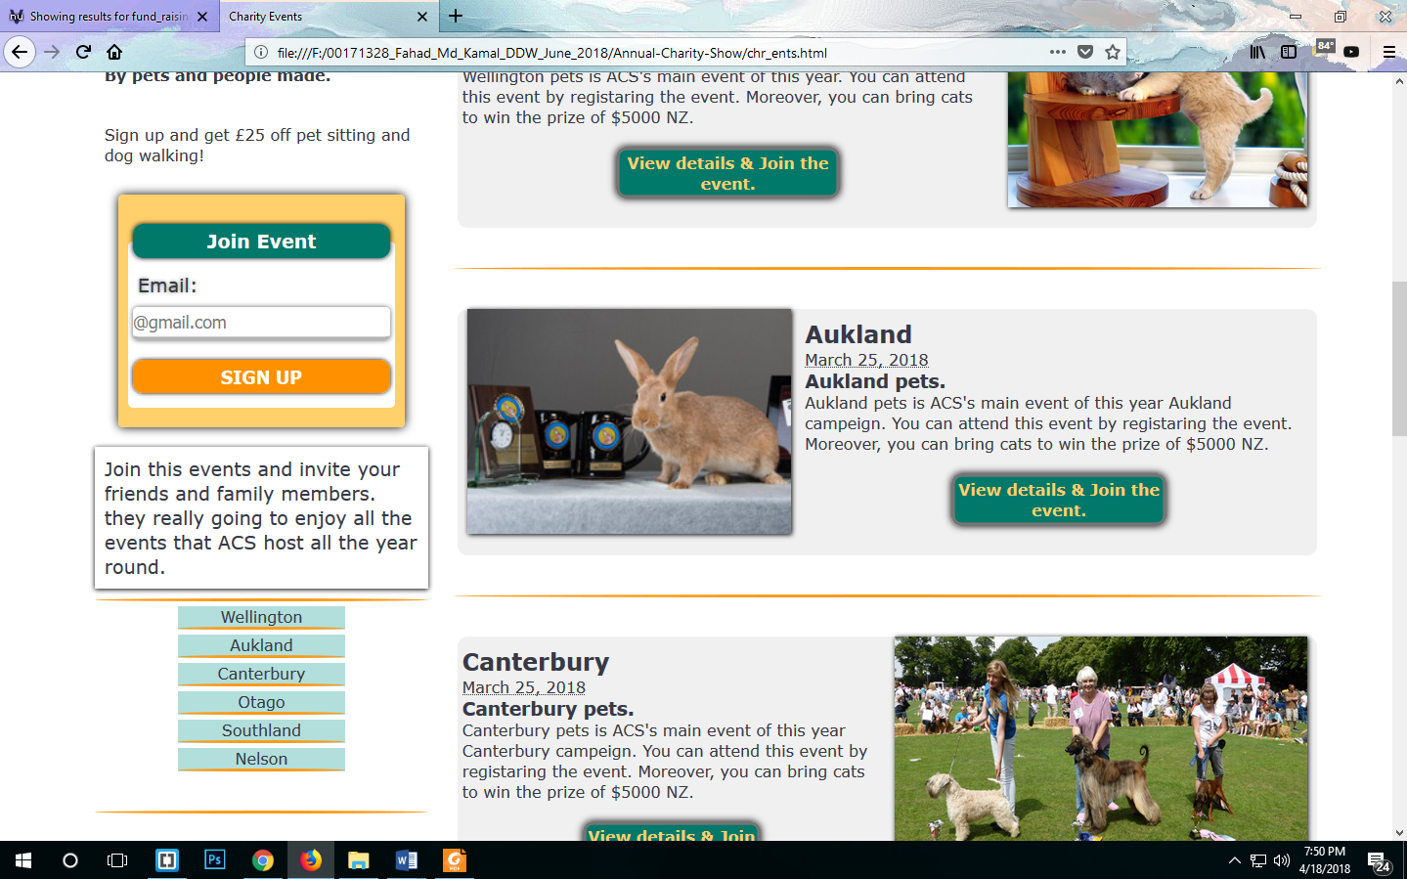

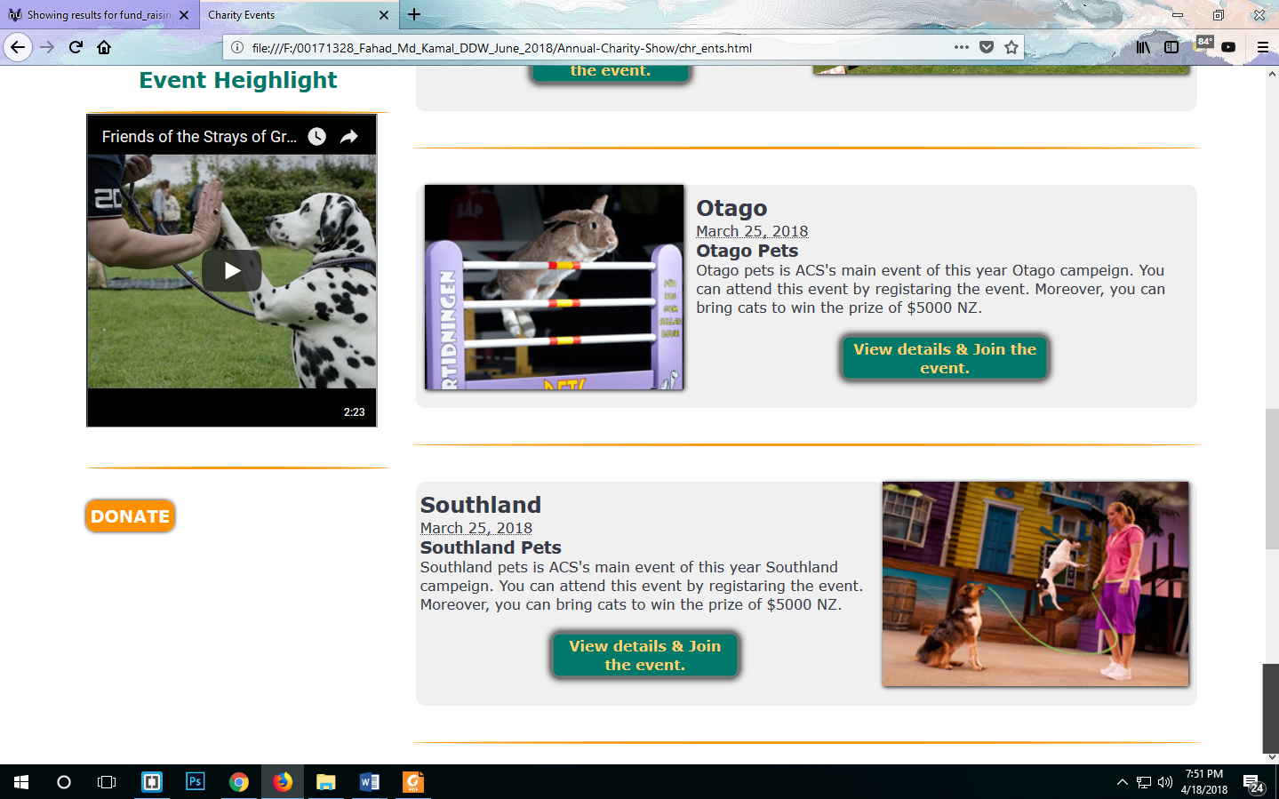

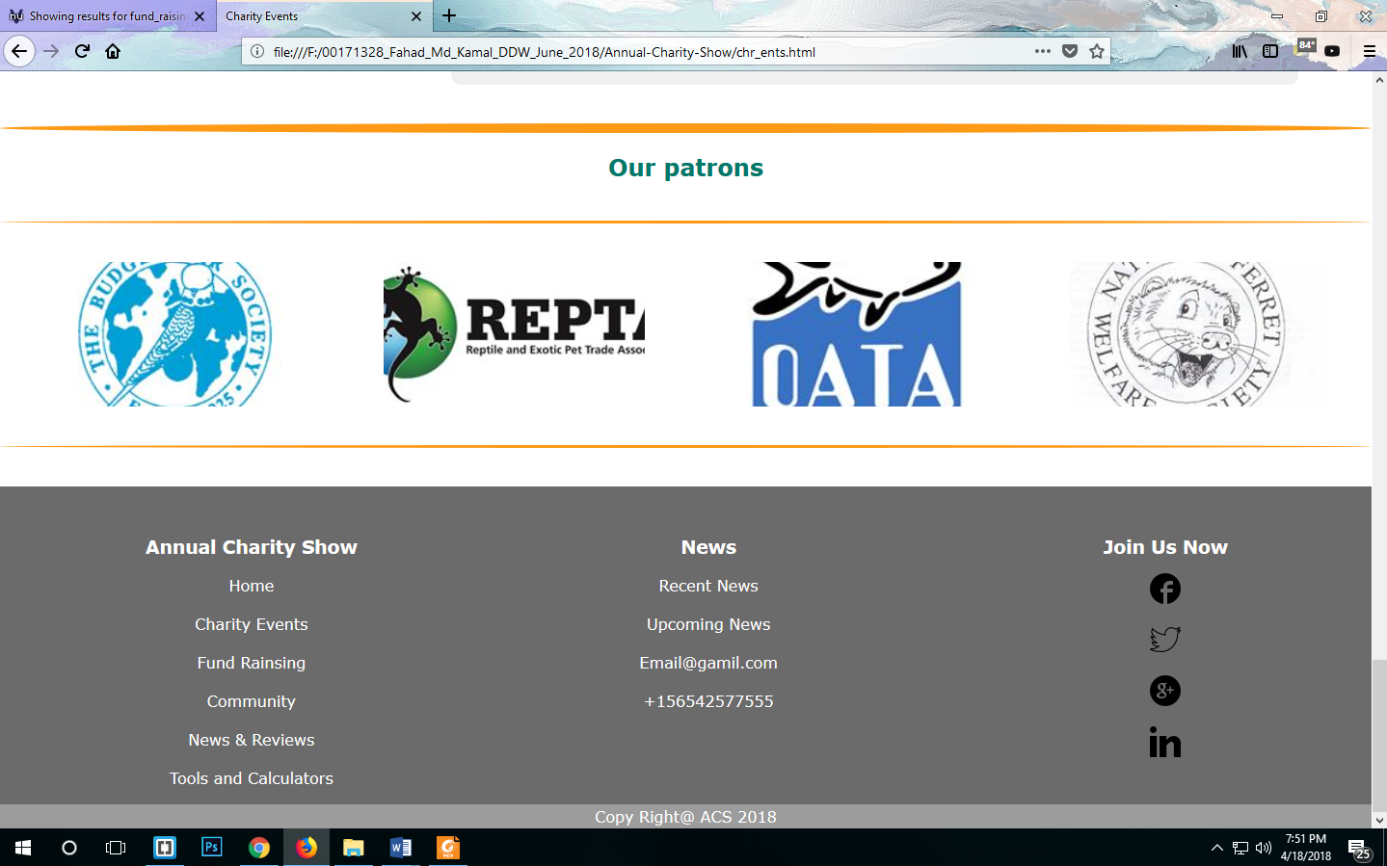

**Chrome View:**

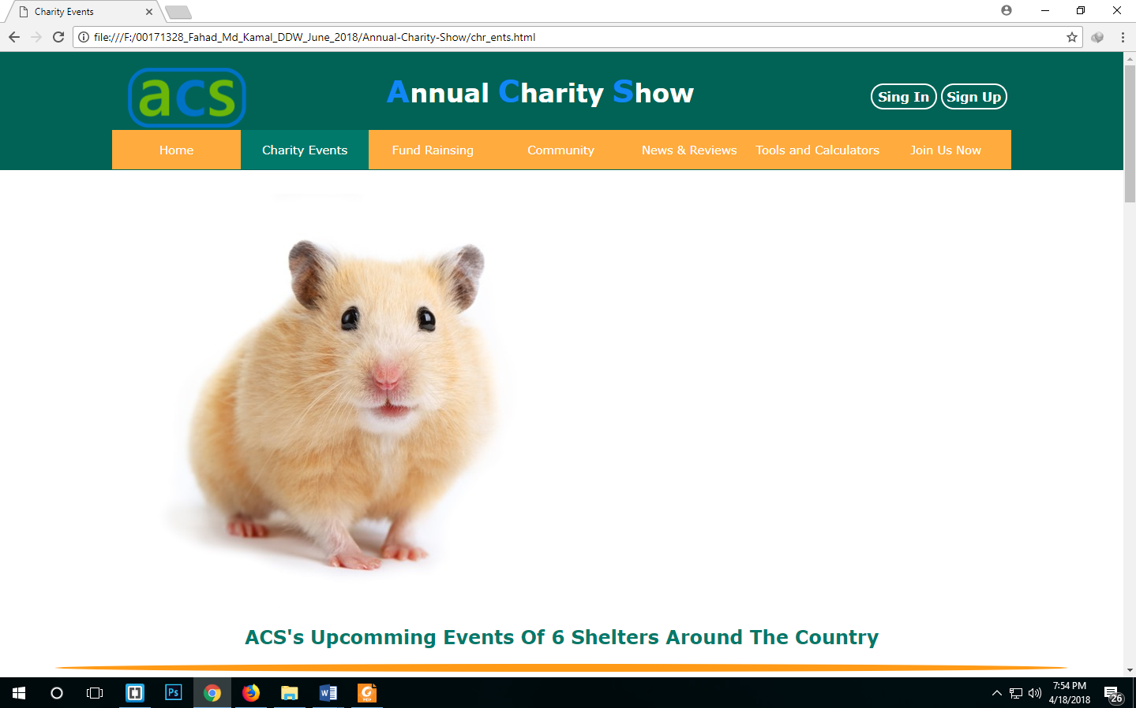



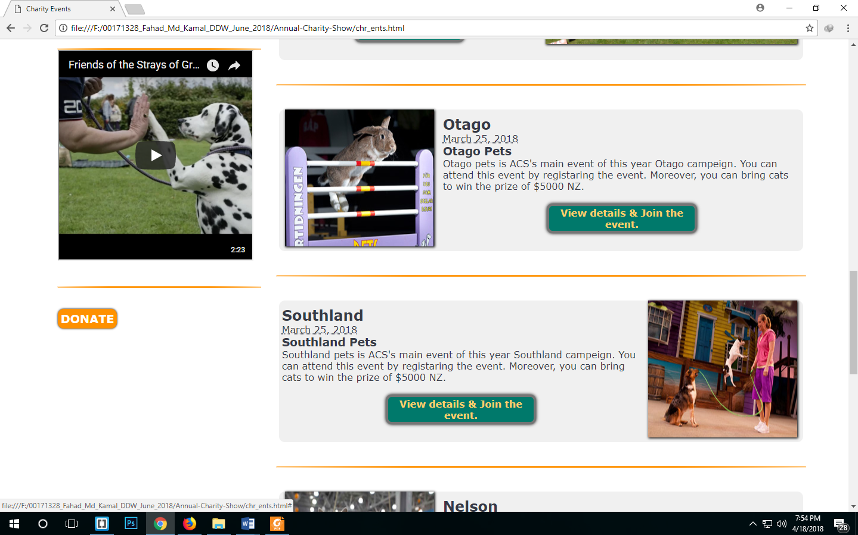

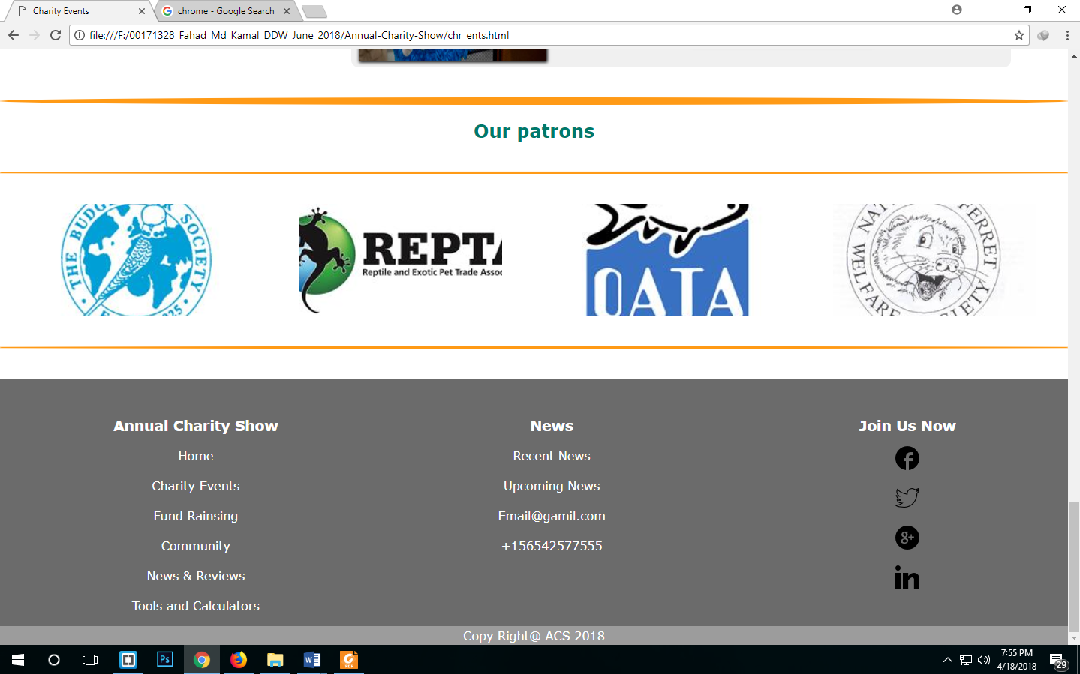

**Fund Raising Page:**

**Mozilla View:**

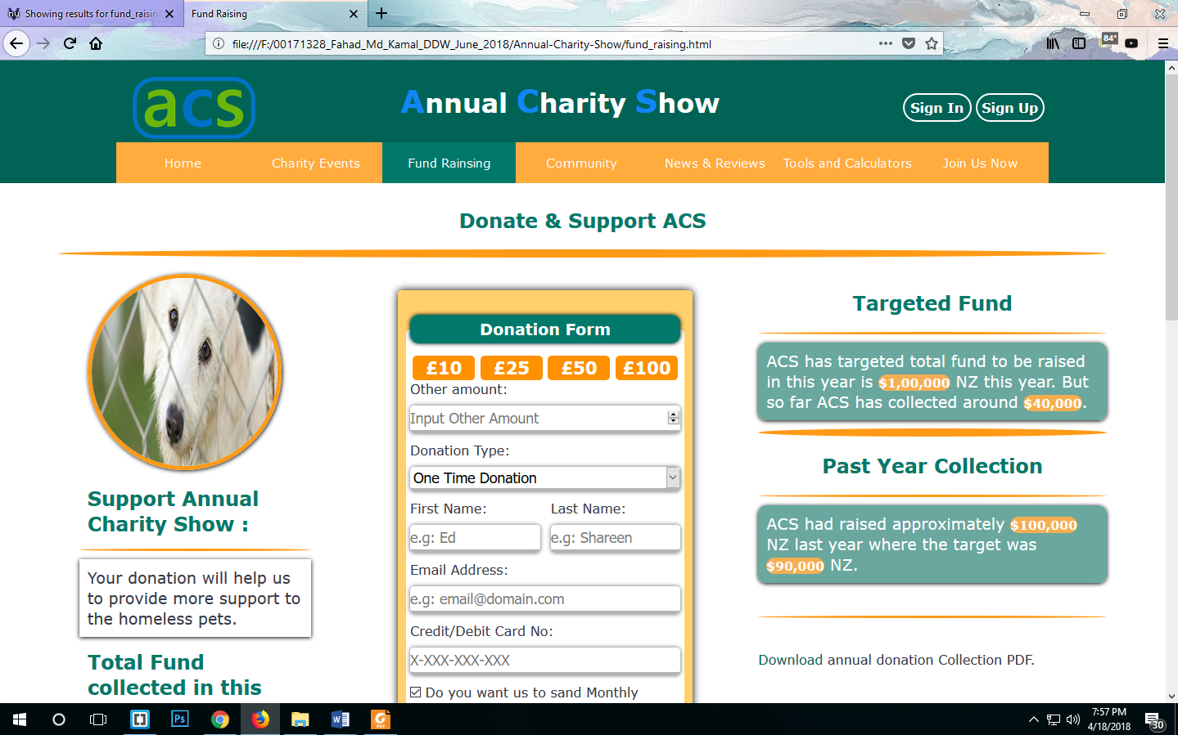

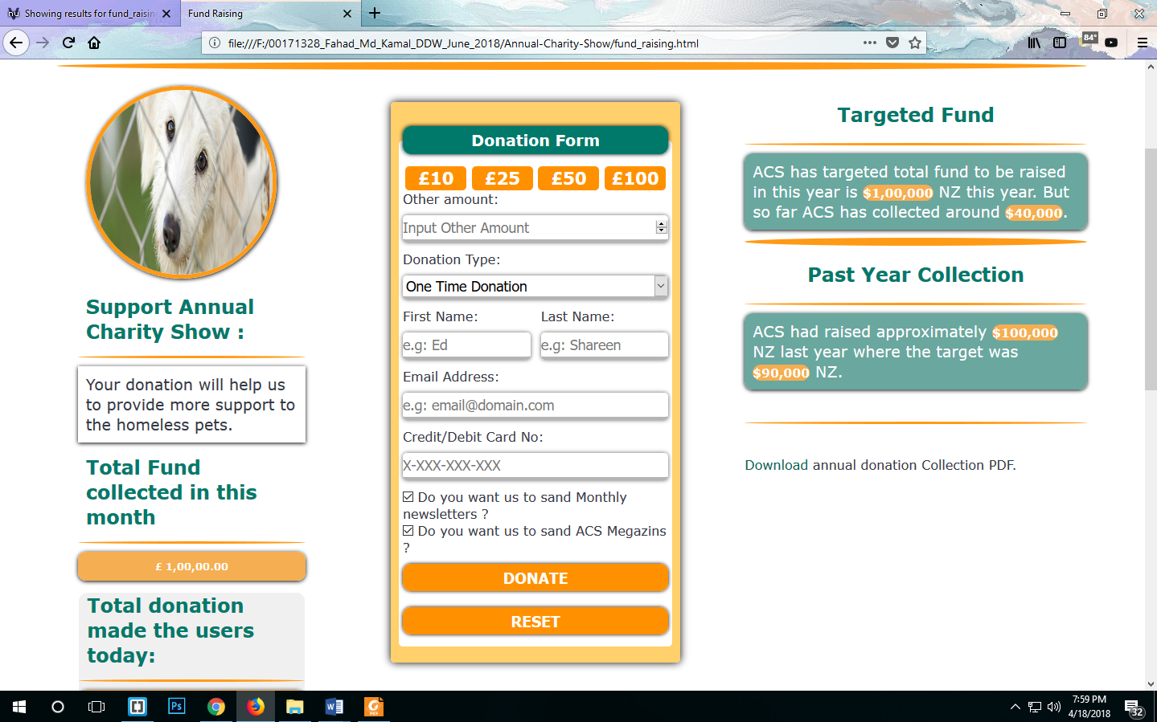

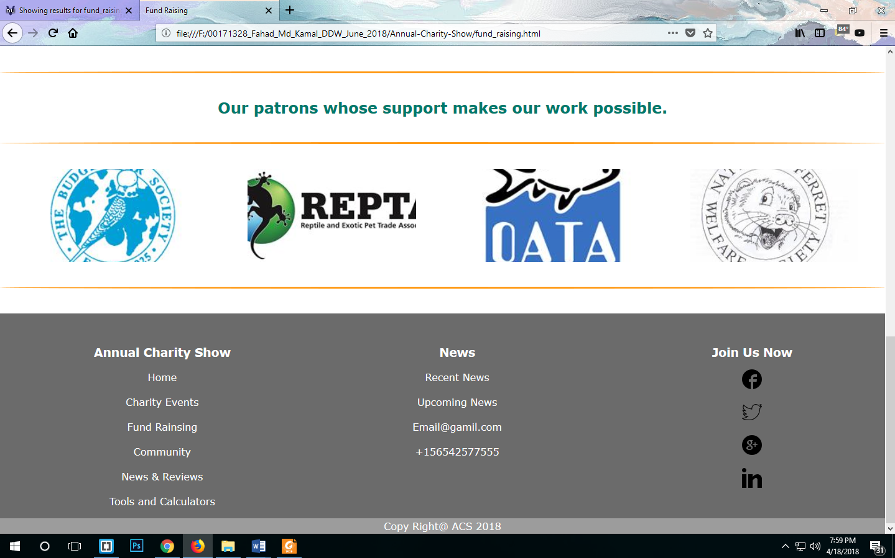

**Chrome View:**

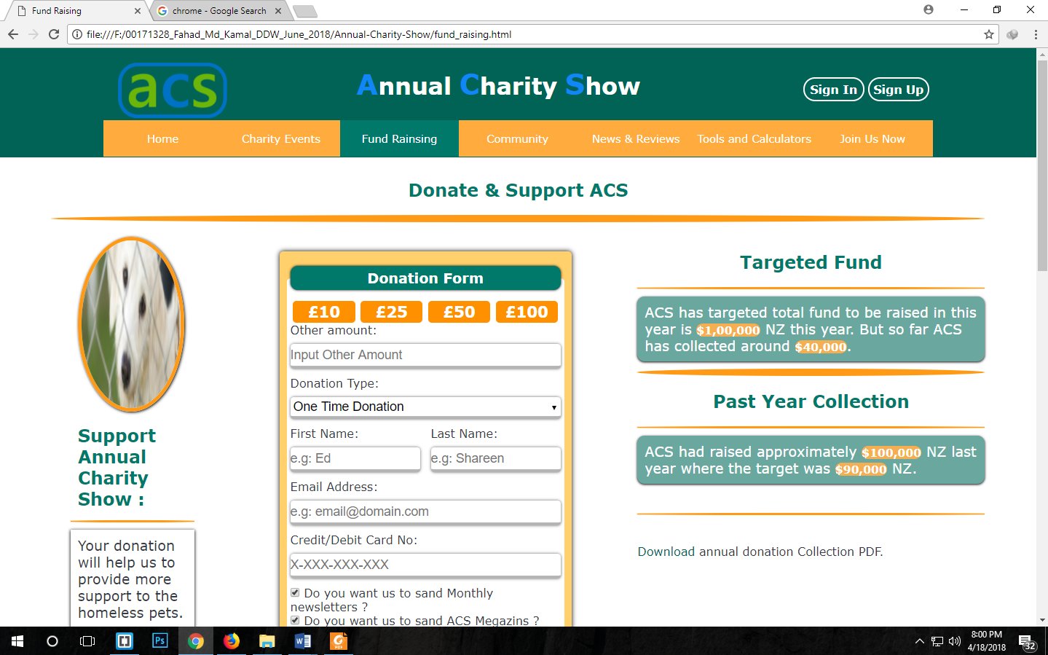

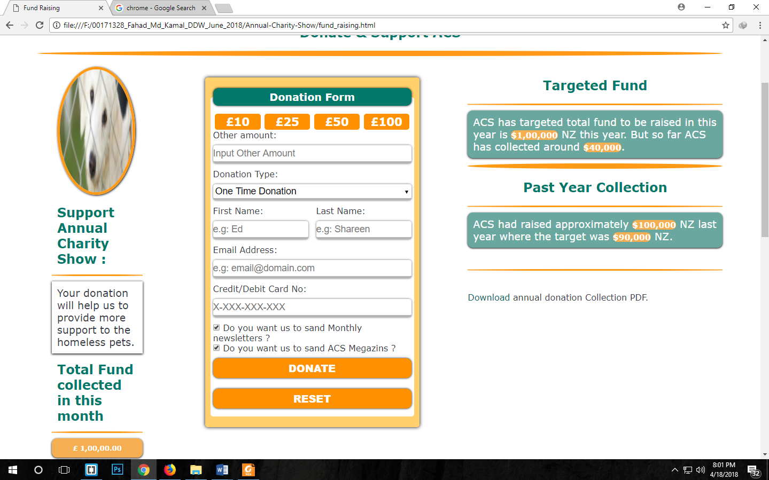

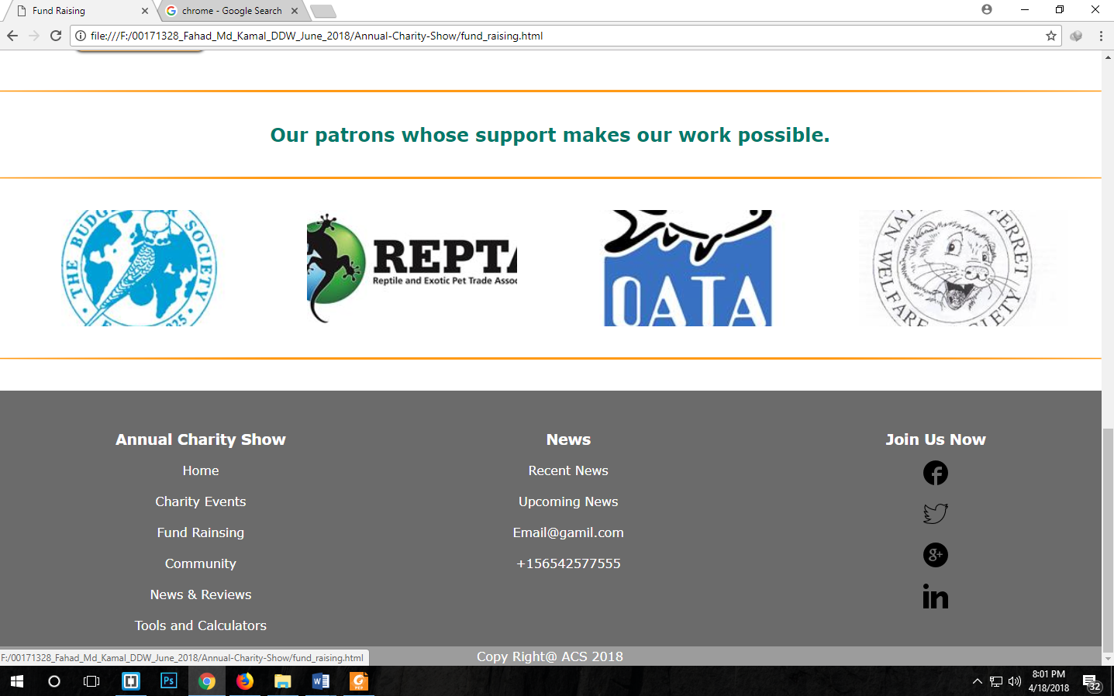

**Community Page:**

**Mozilla View:**

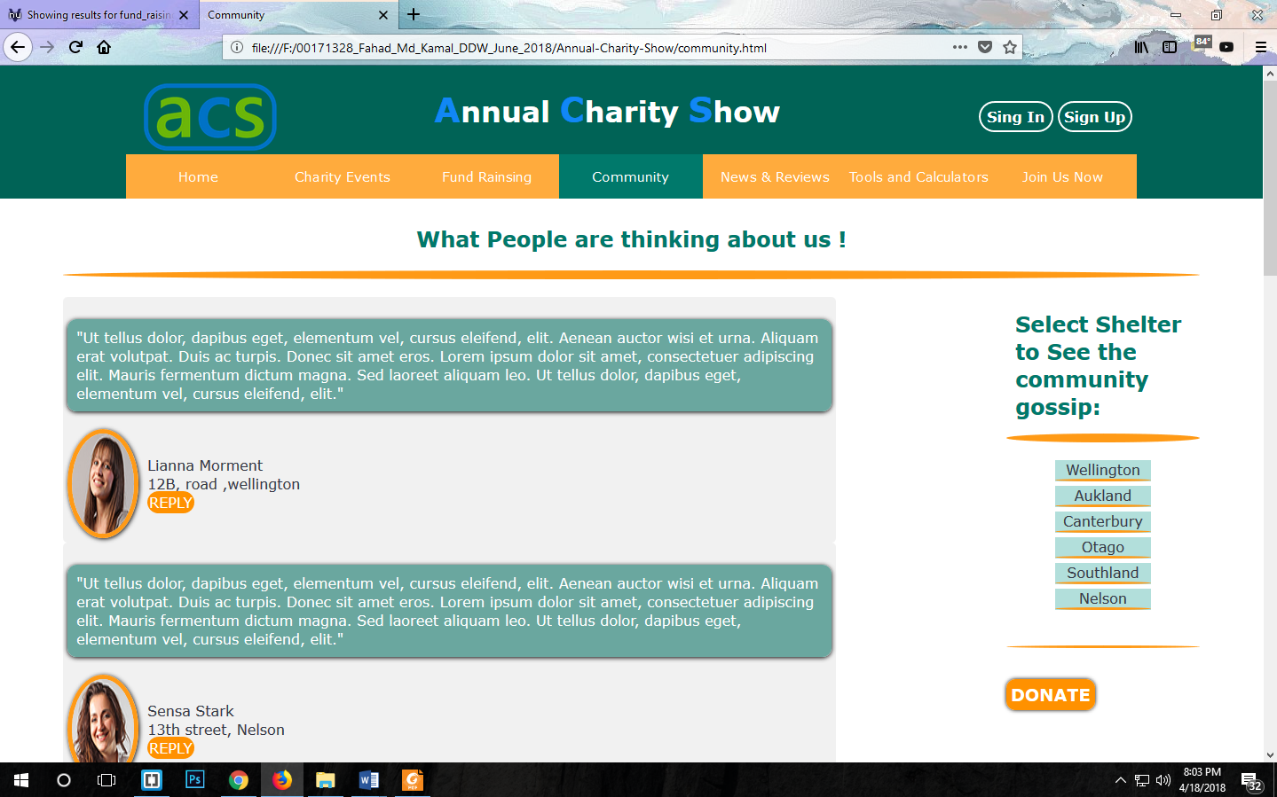

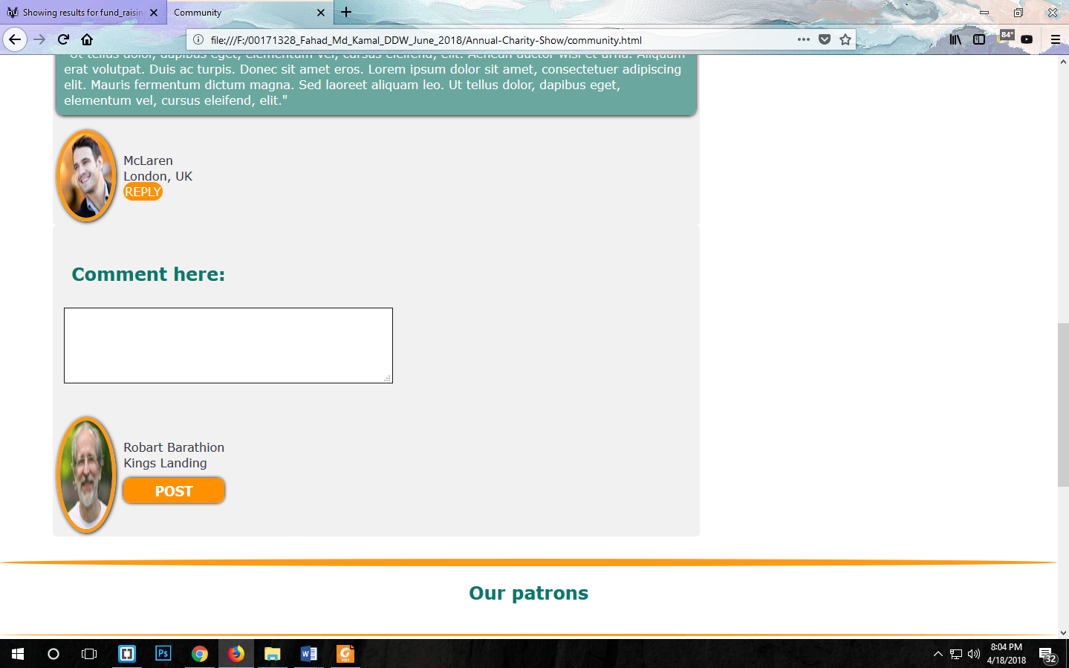

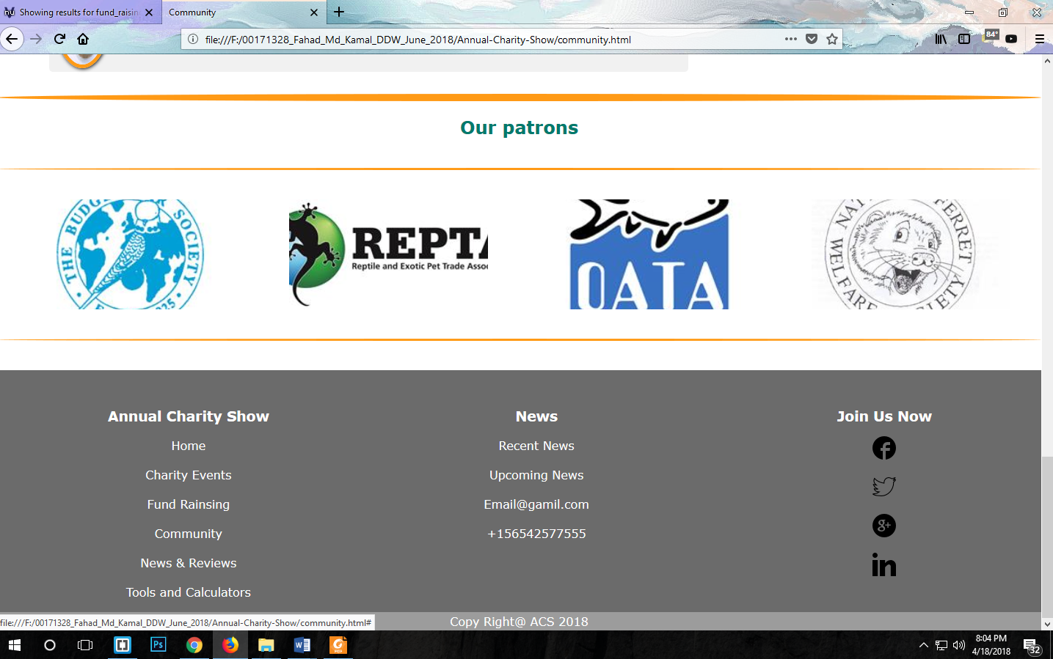

**Chrome View:**

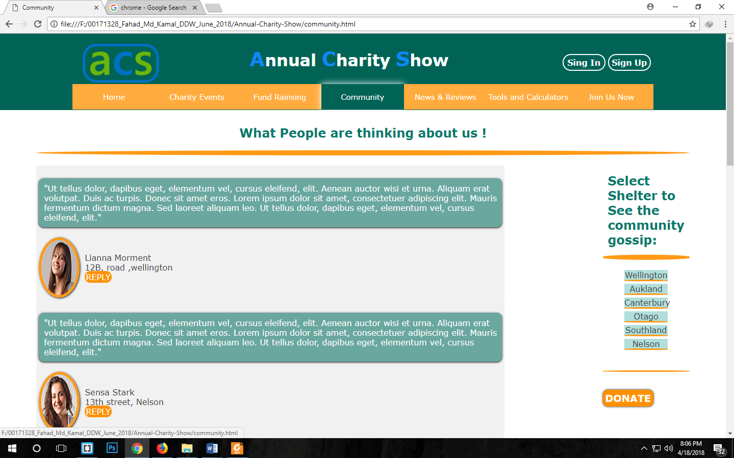

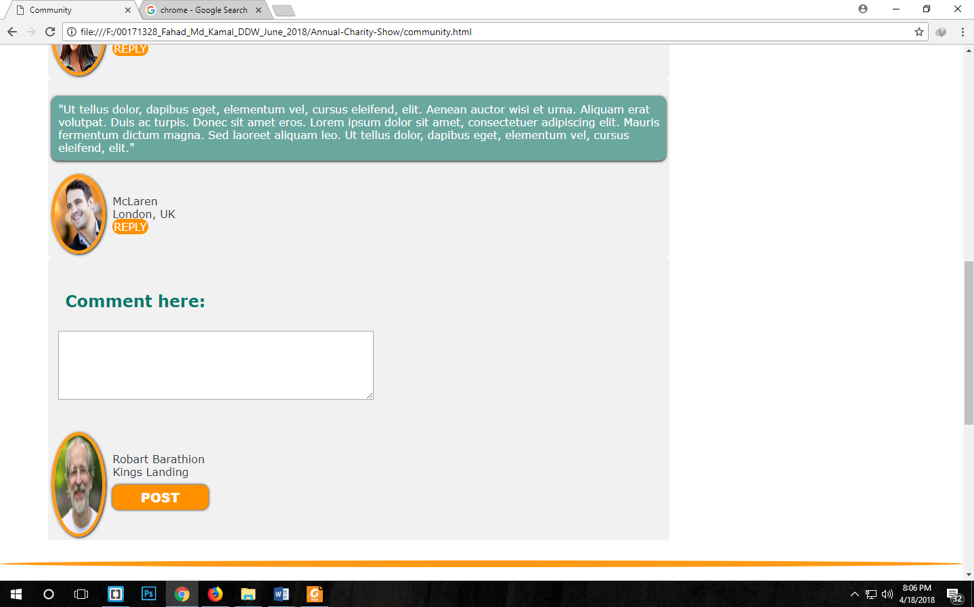

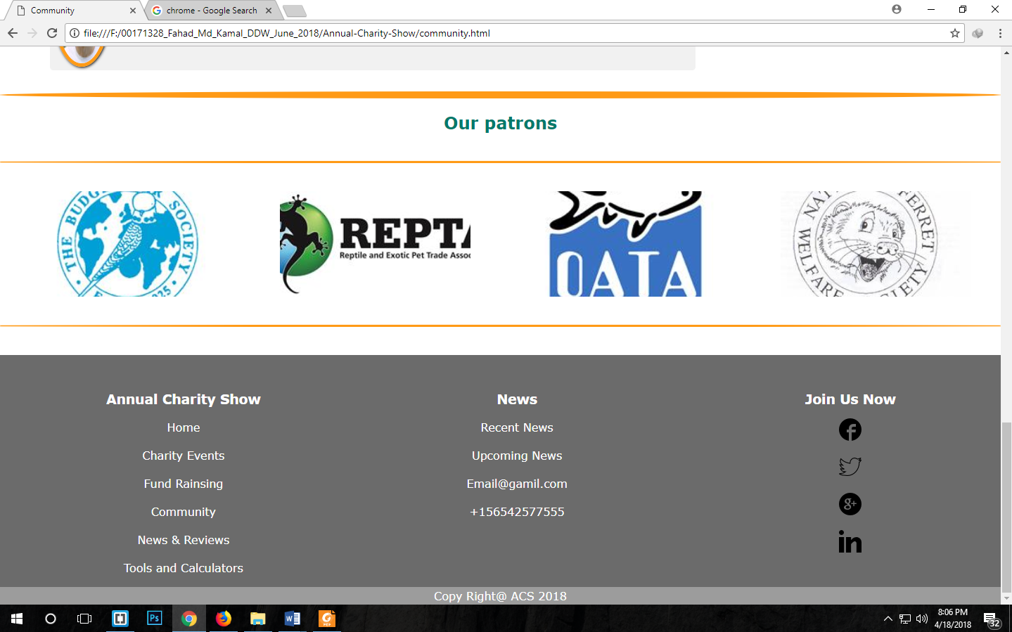

**News & Reviews page:**

**Mozilla View:**

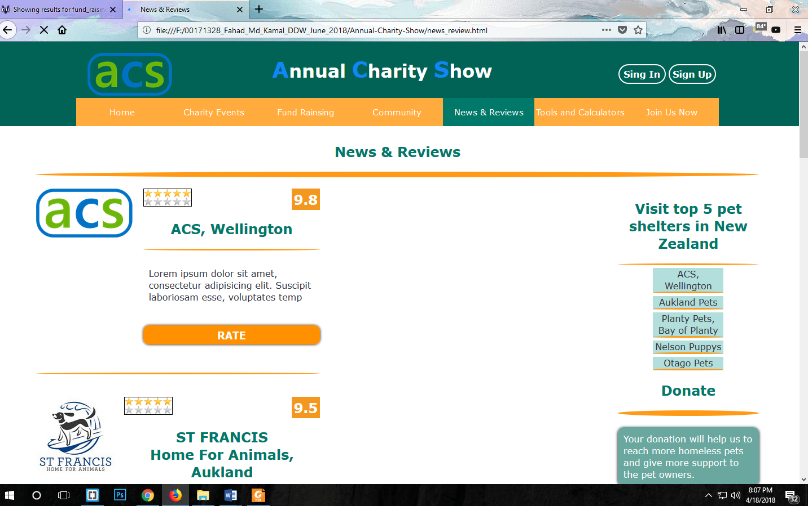

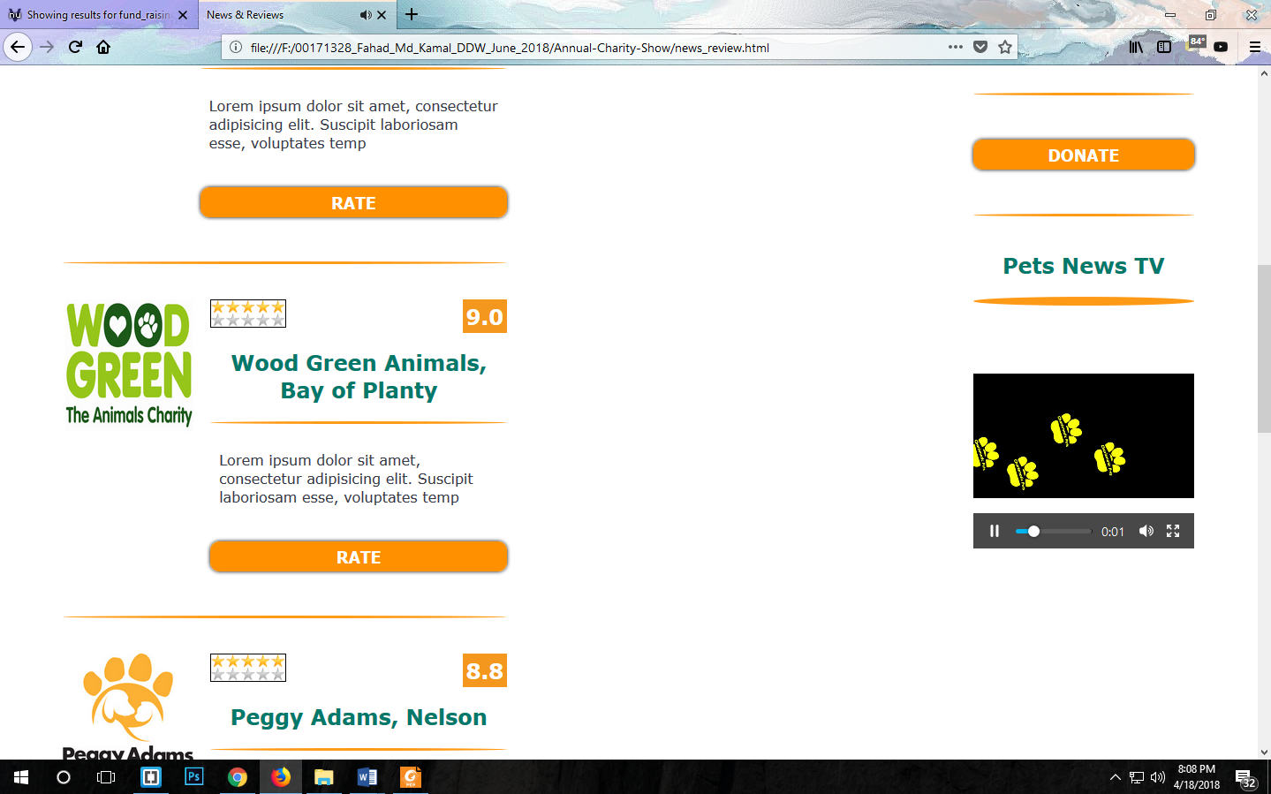

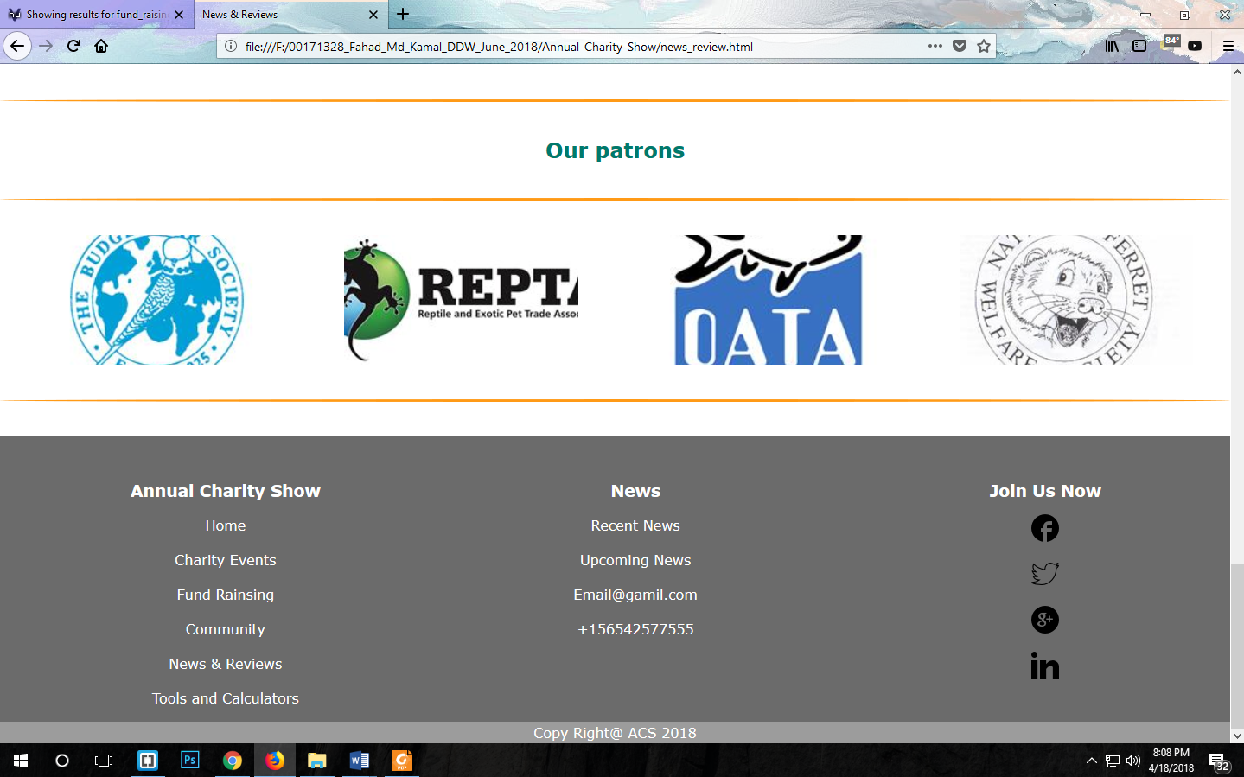

**Chrome View:**

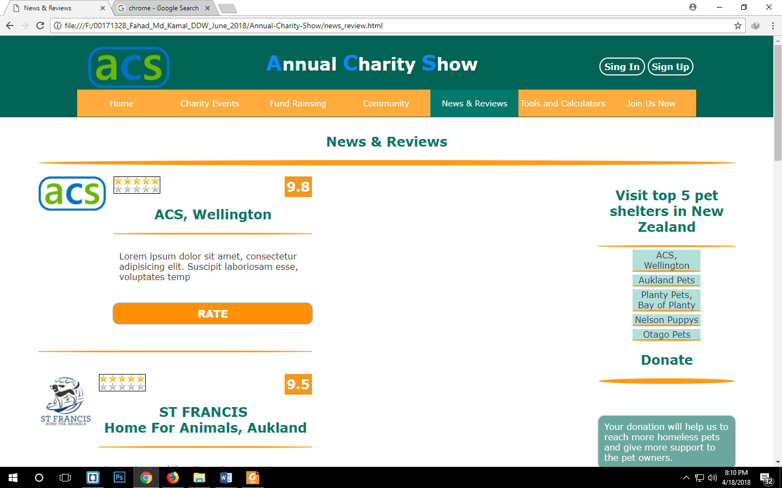

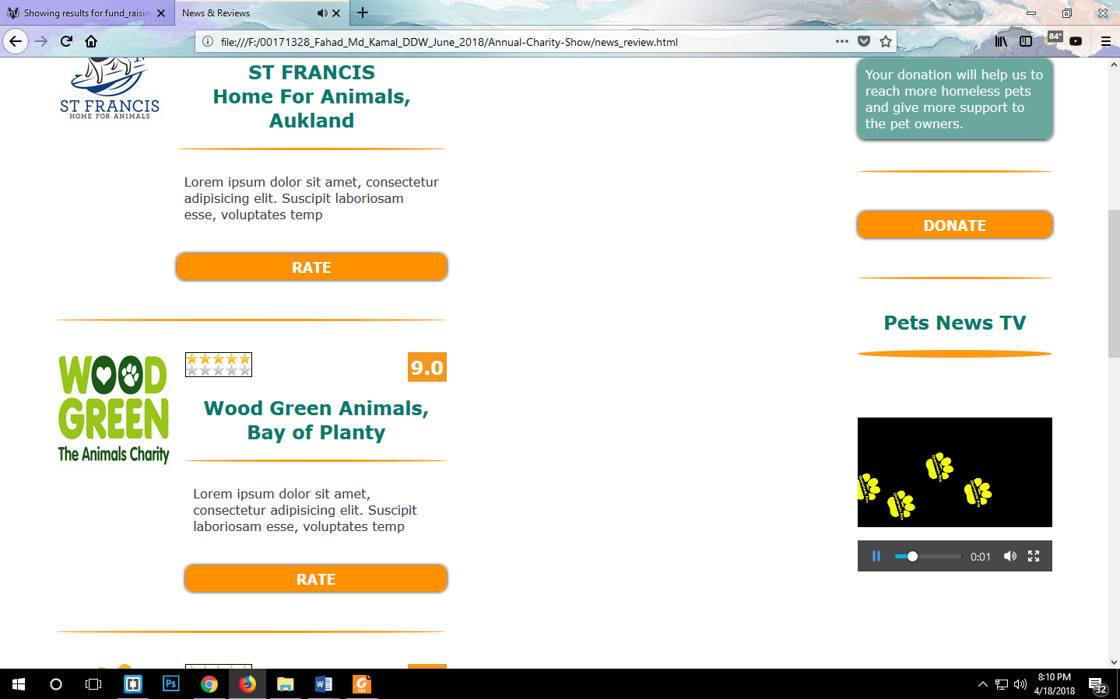

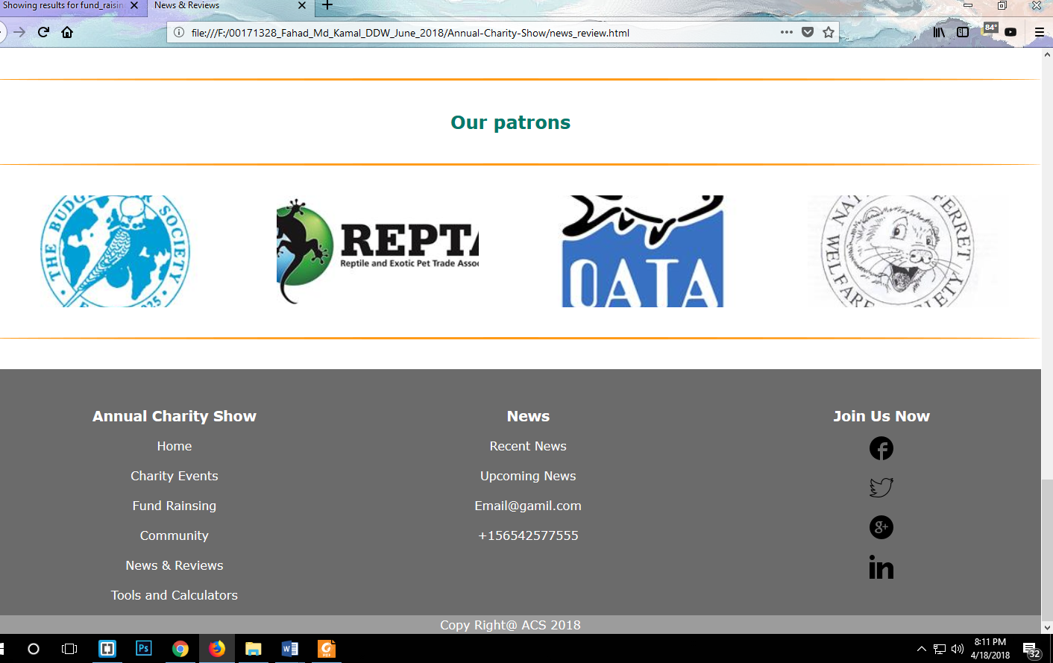

**Tools and Calculators Page:**

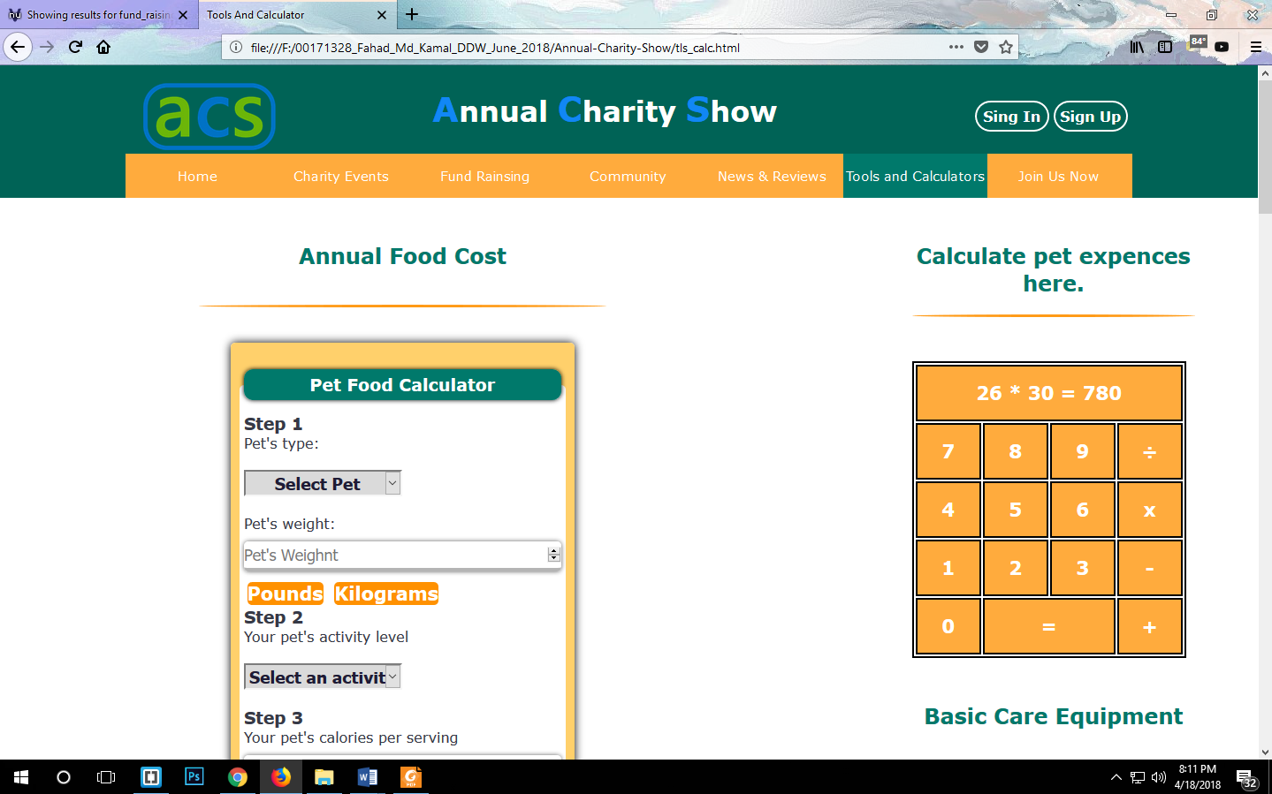

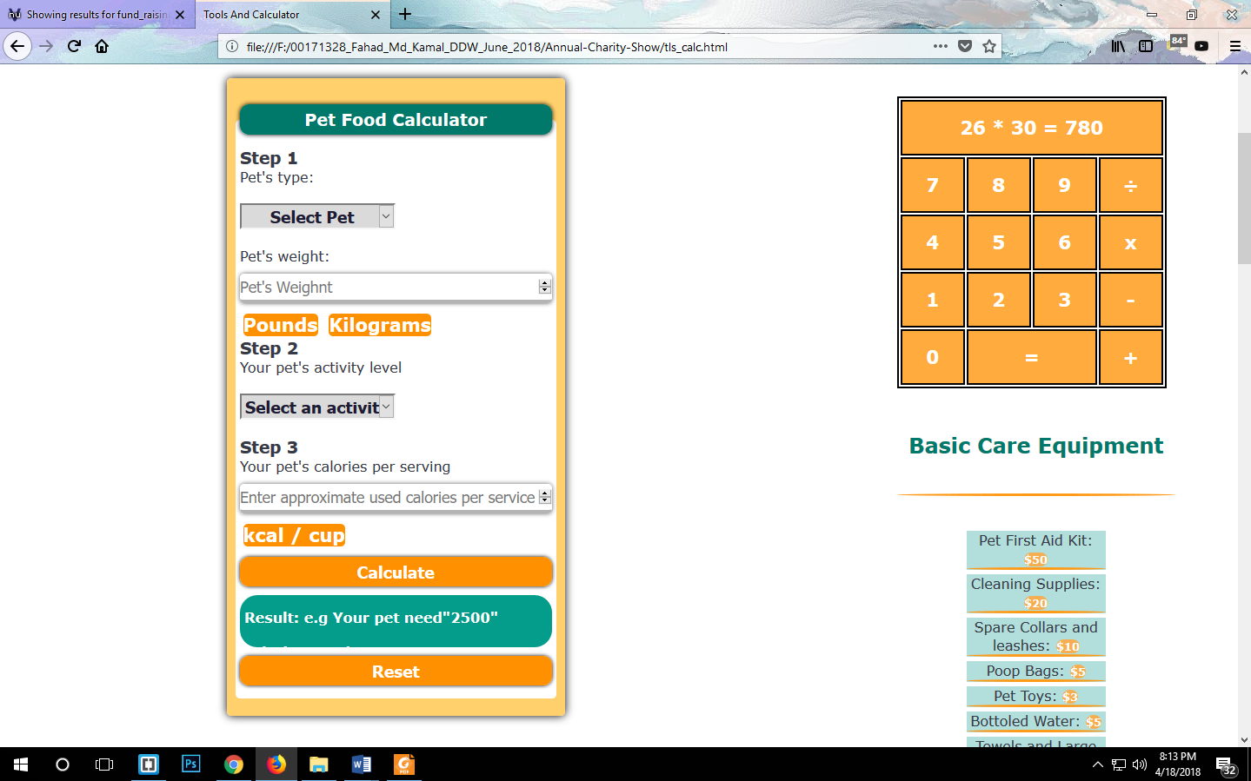

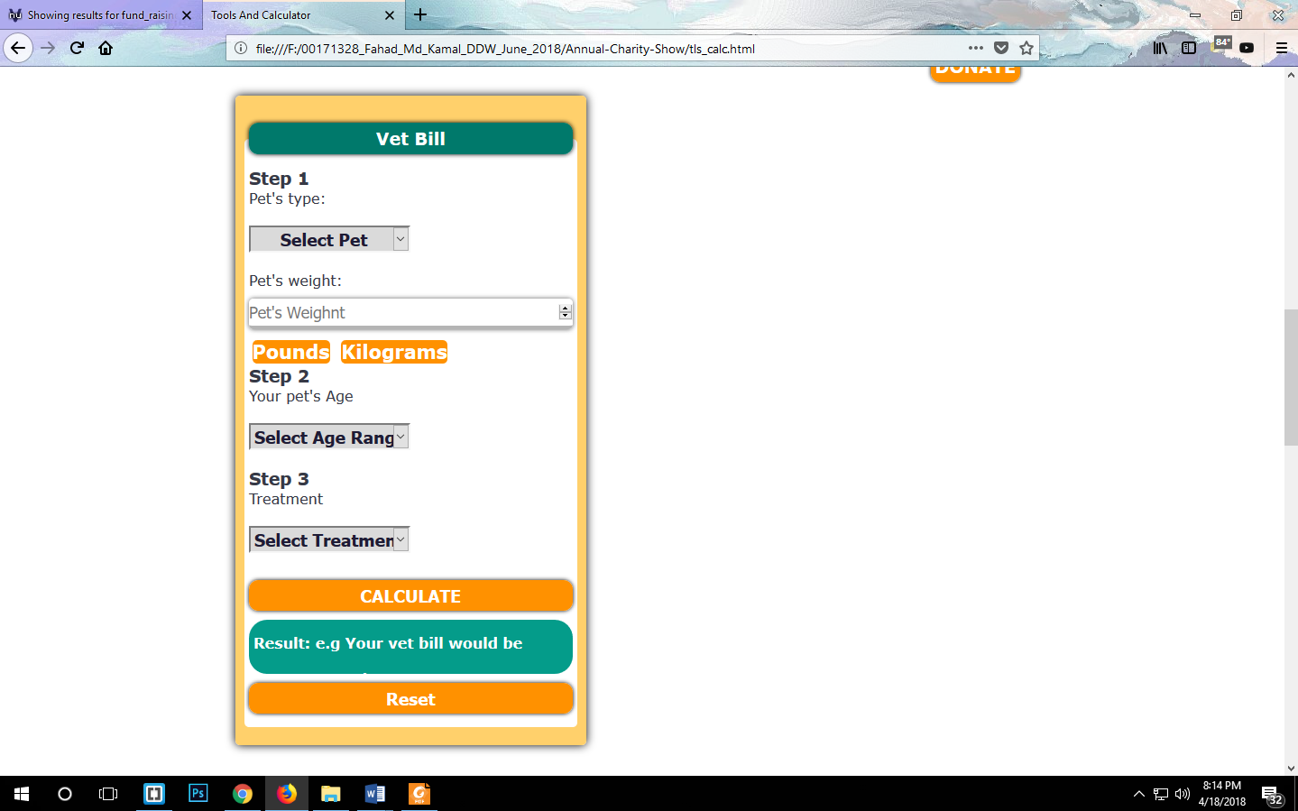

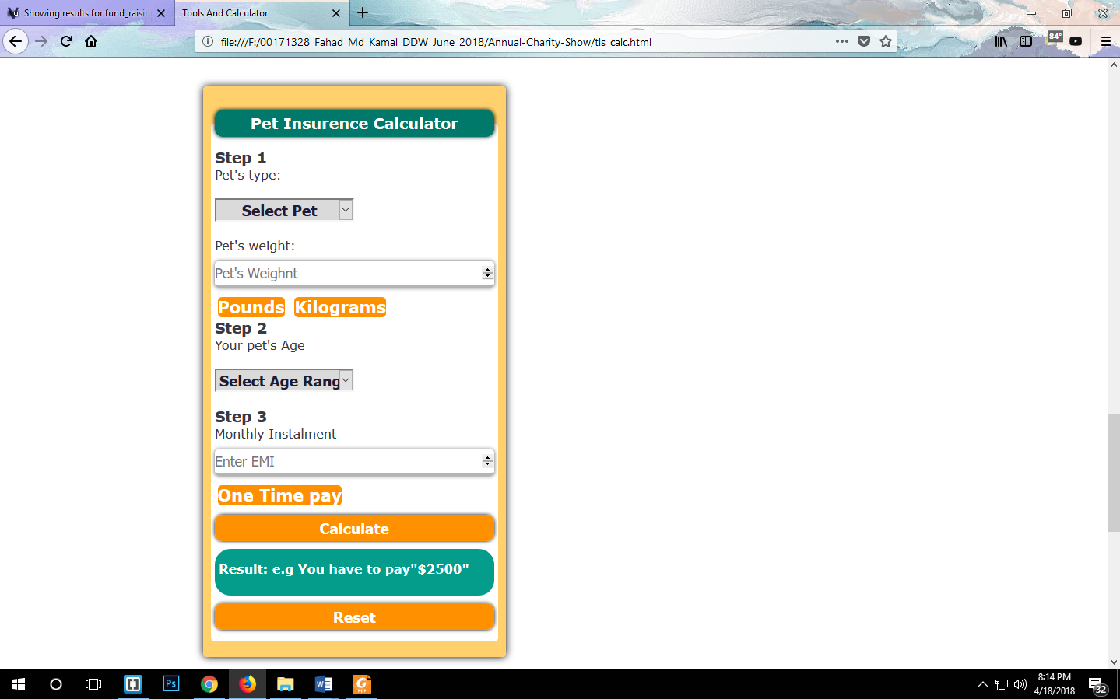

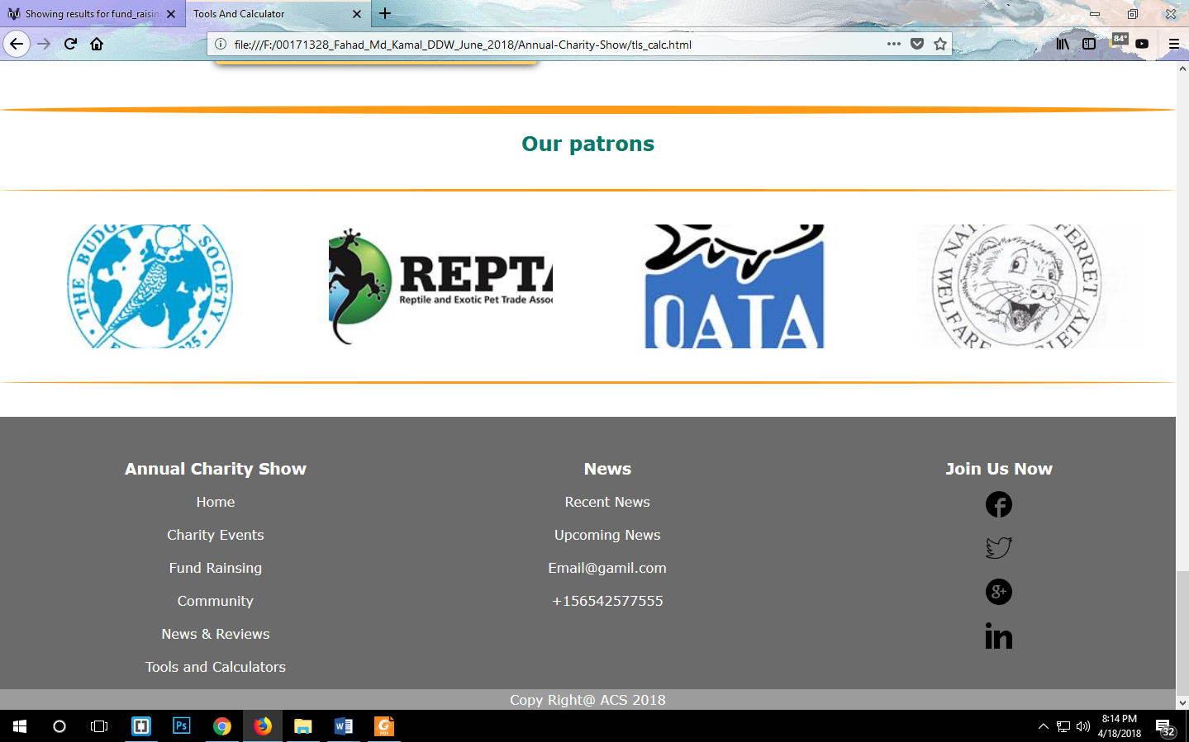

**Chrome View:**

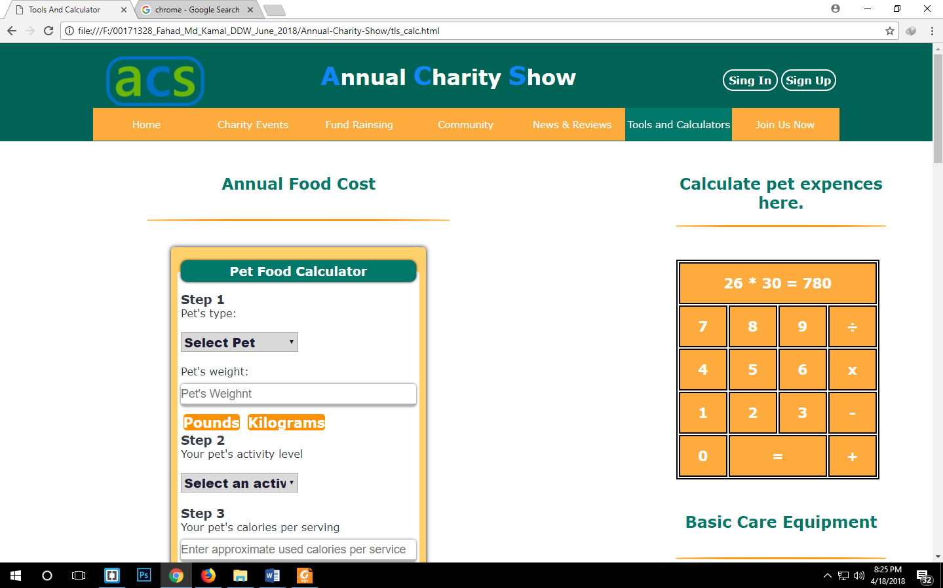

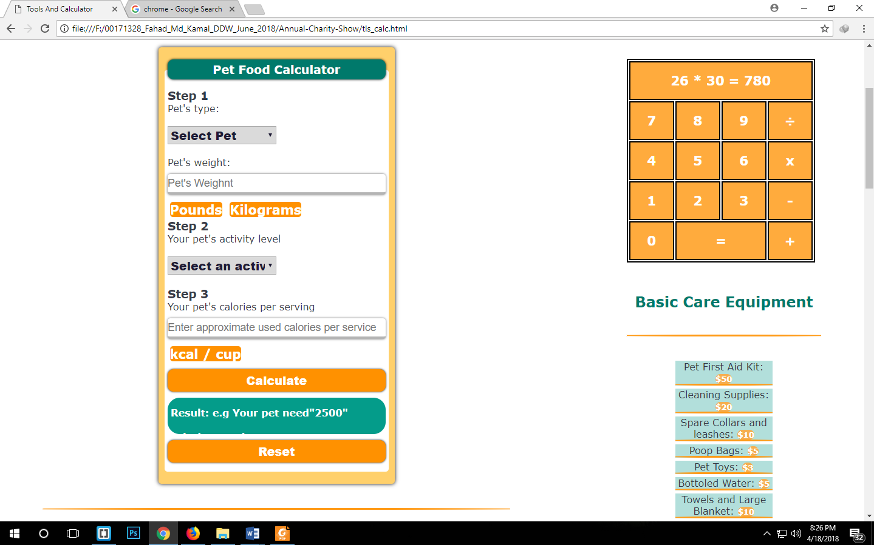

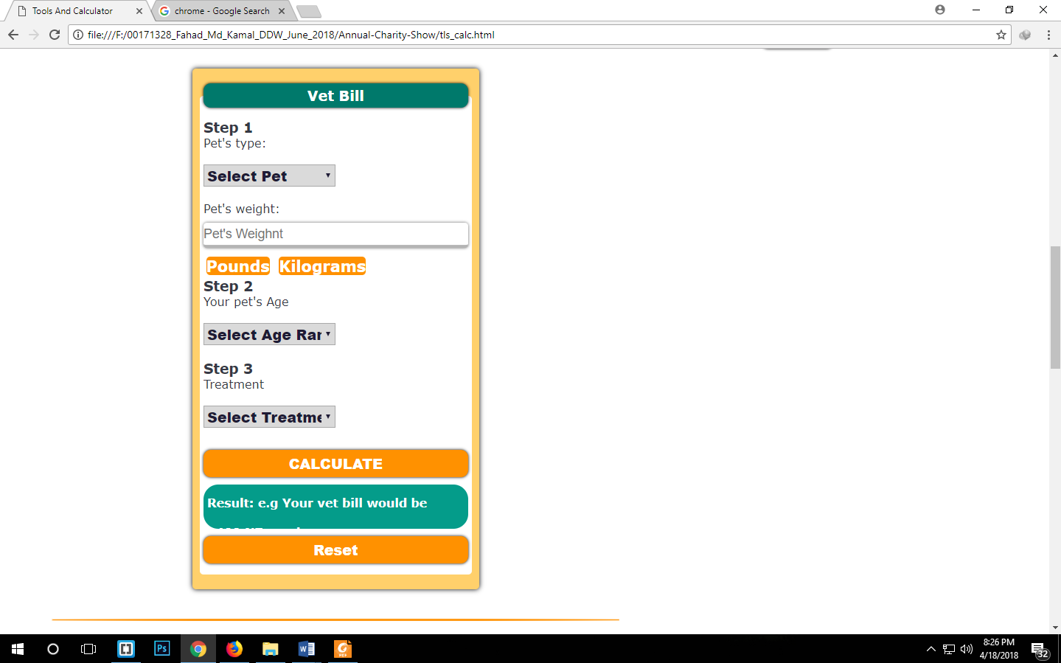

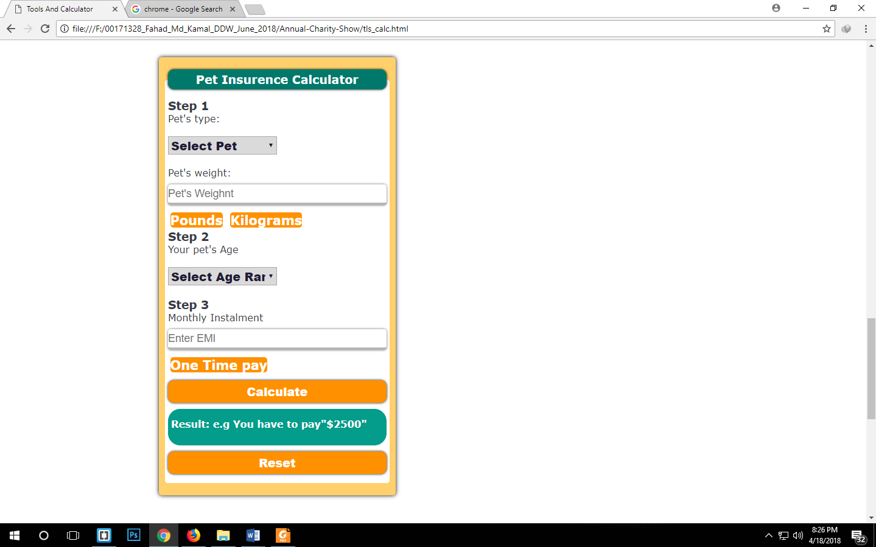

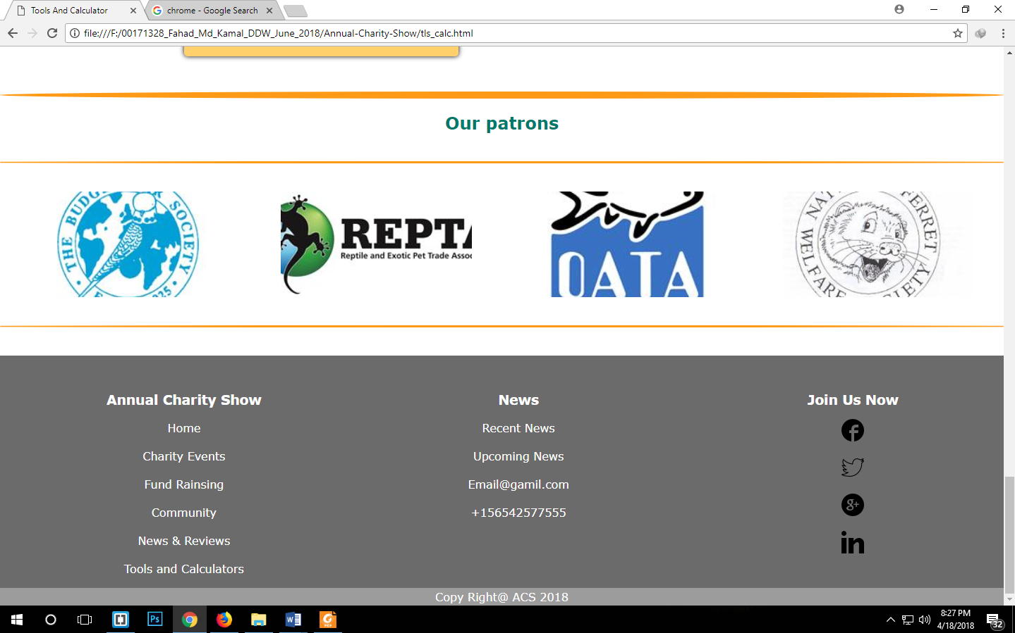

**Join Us Now Page:**

**Mozilla View:**

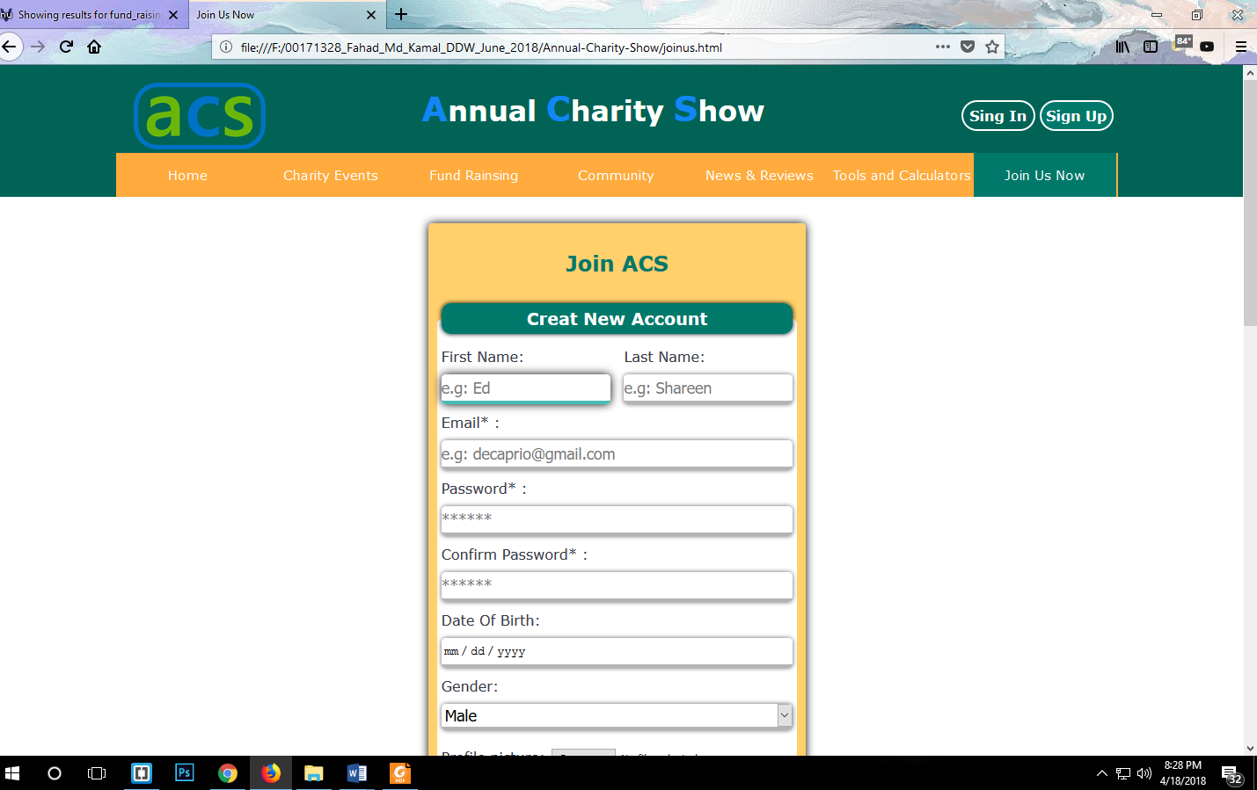

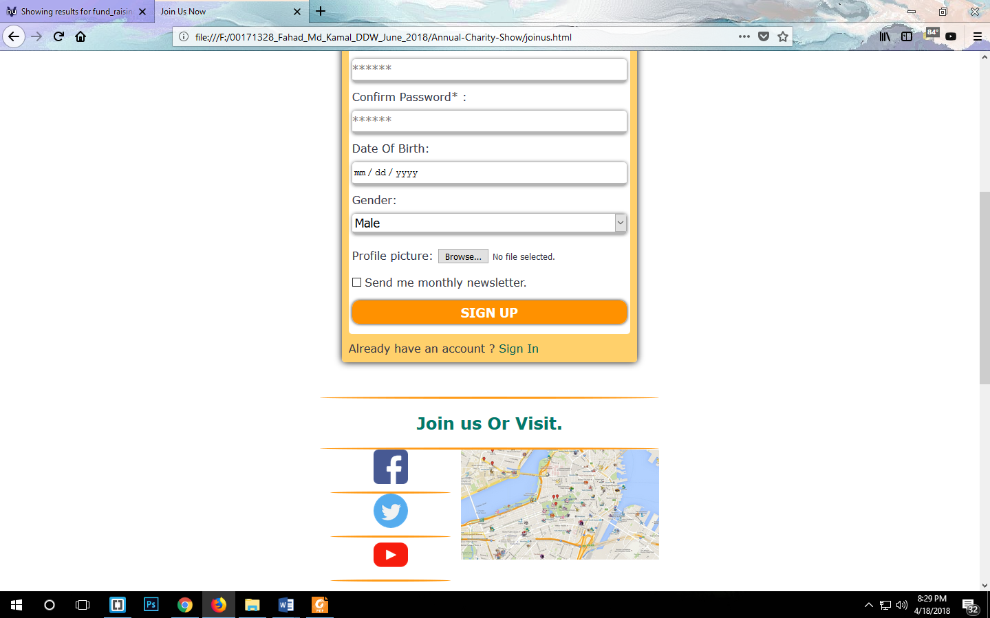

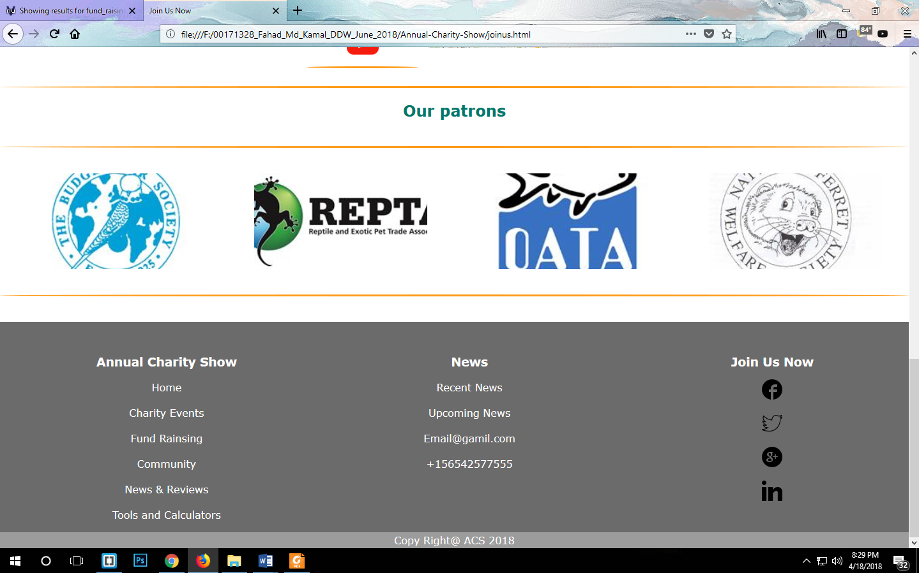

**Chrome View:**

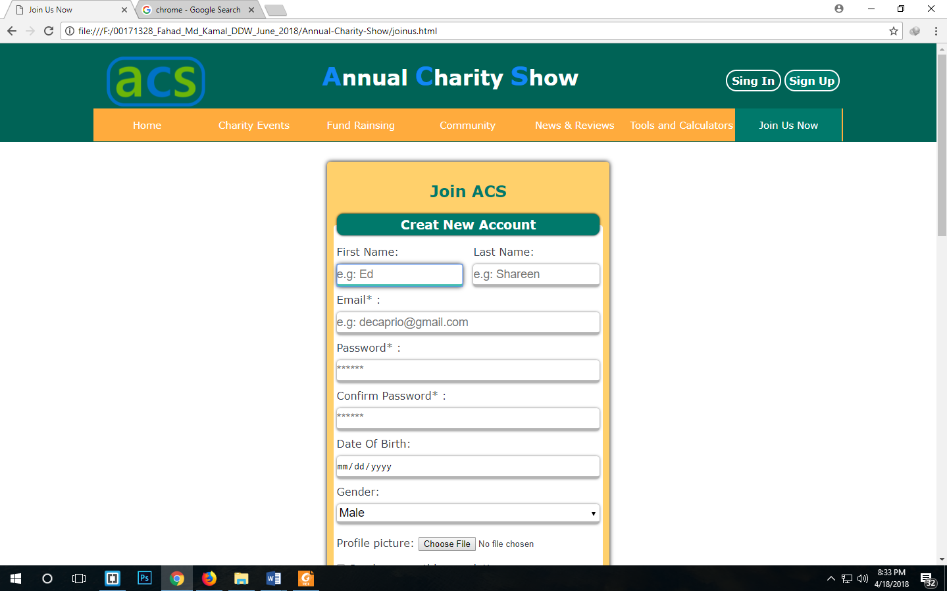

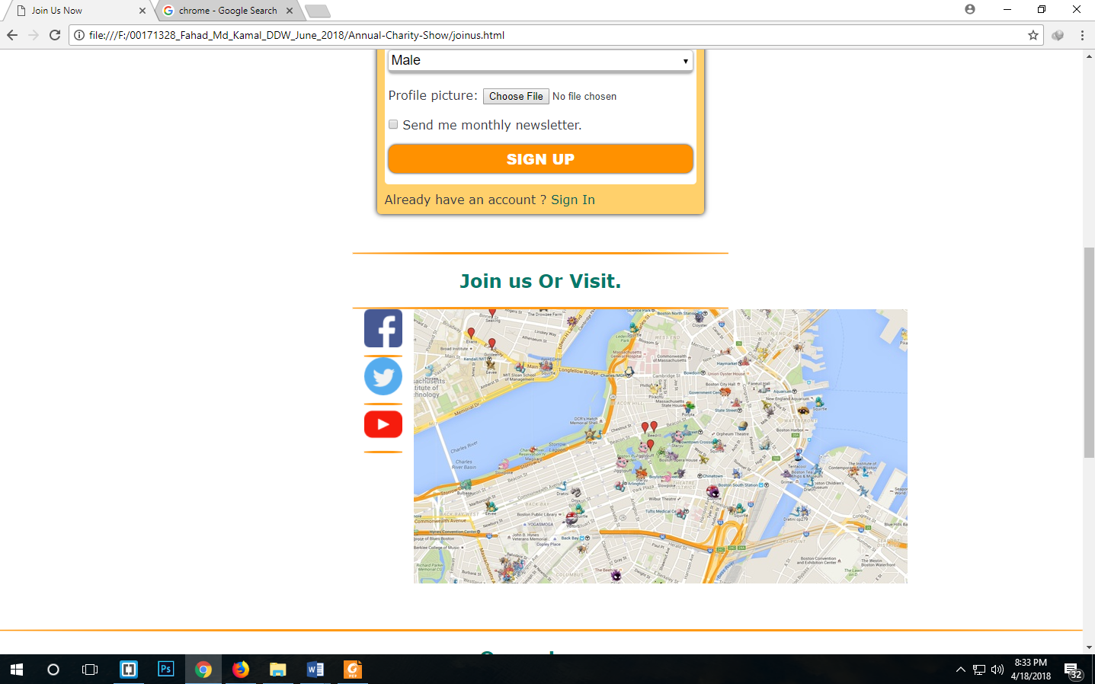

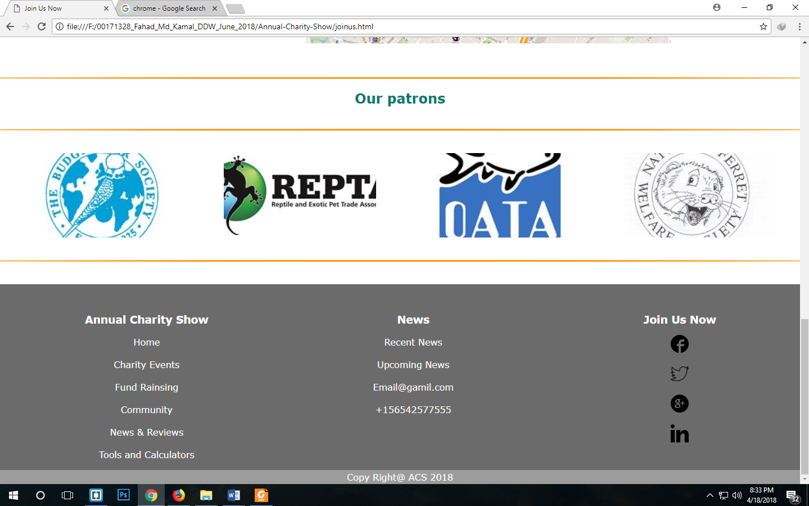

**Sign in Page:**

**Mozilla View:**

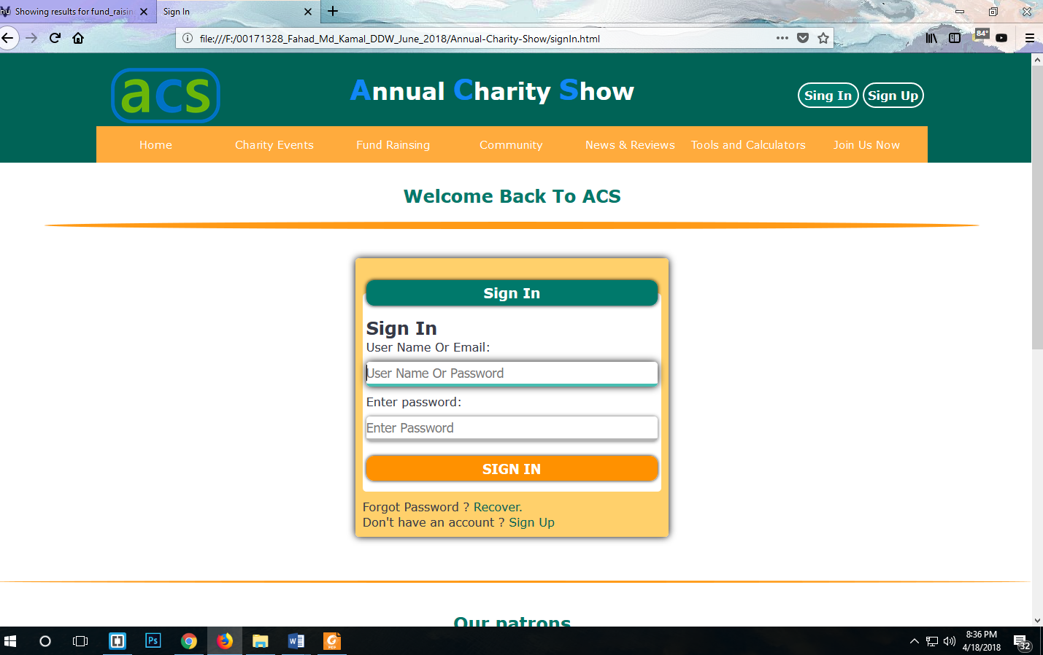

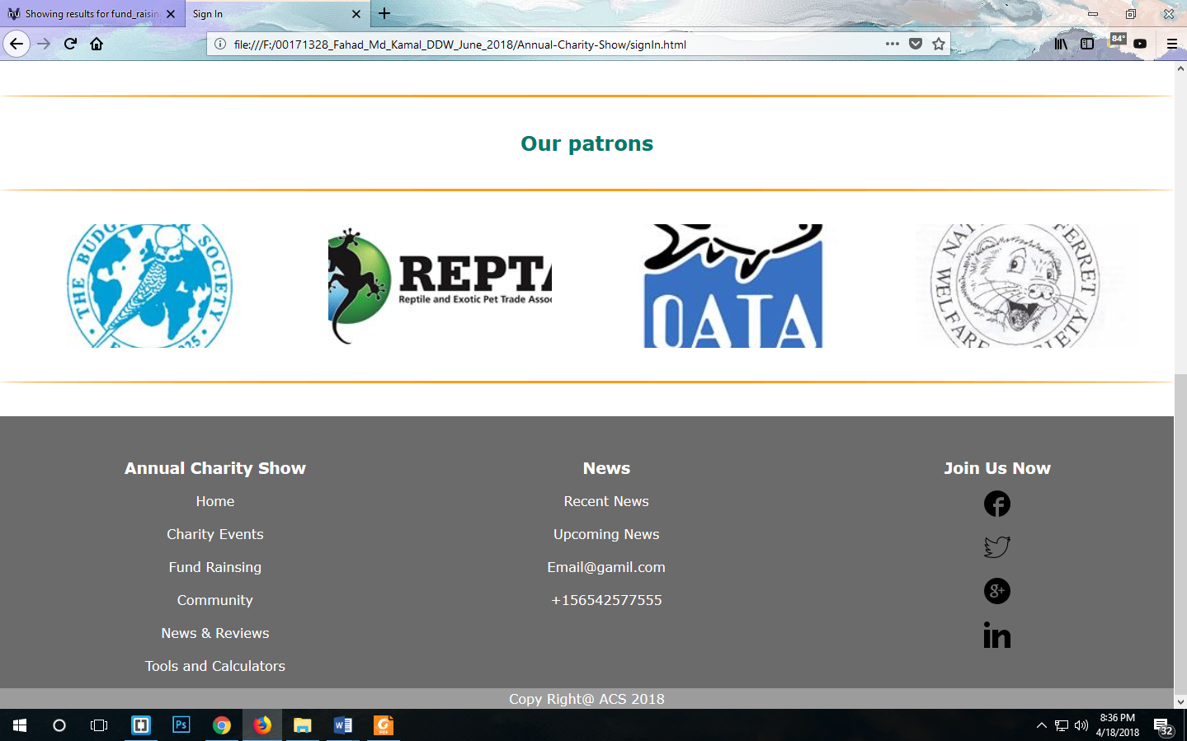

**Chrome View:**

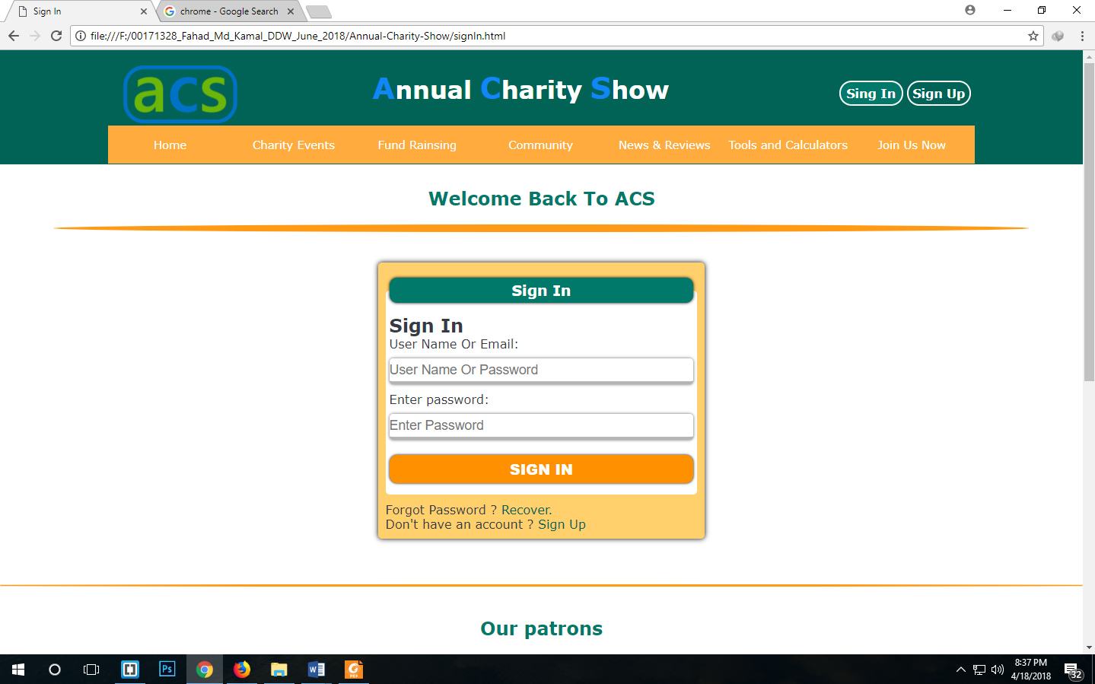

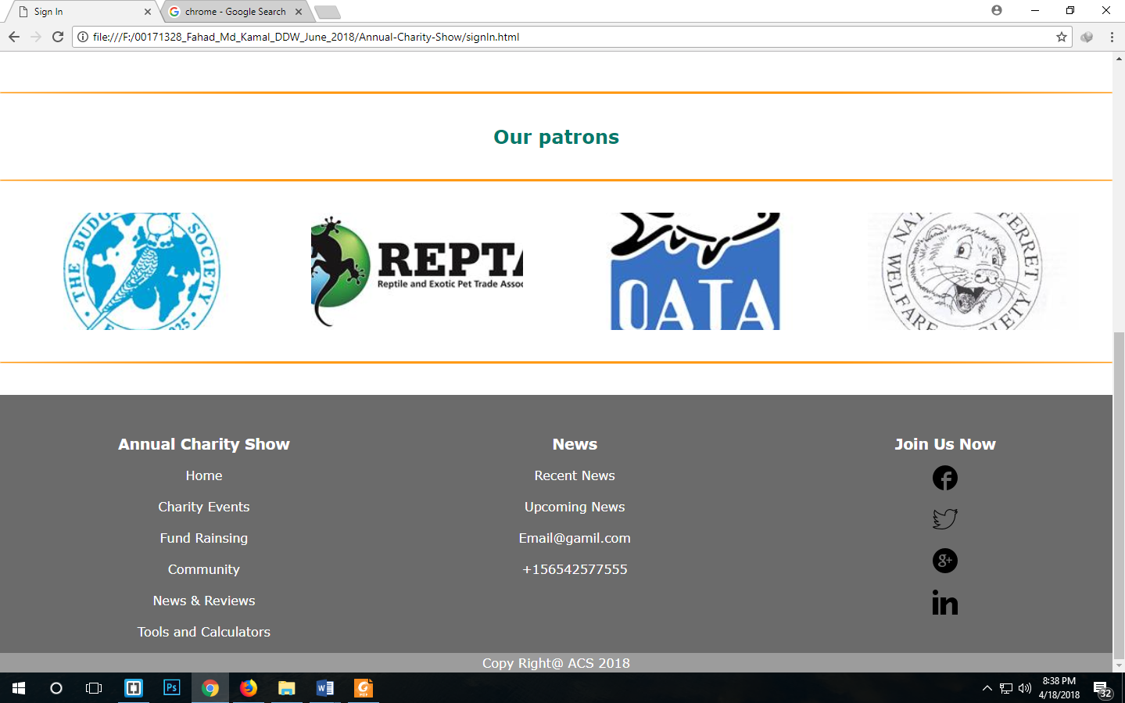

Report of testing the developed website of ACS in Two Browsers named Mozilla Firefox and chrome browser:

**Outstanding Problems:** There are many problems in two browsers. Some of them are very acute and some are minor:

**Home page Sign in Form**: Here place holder text was exceeding the textbox length on Firefox browser but in Chrome it shows fine.

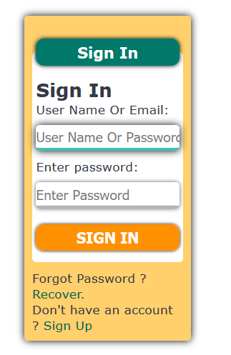

Figure 1: Mozilla View

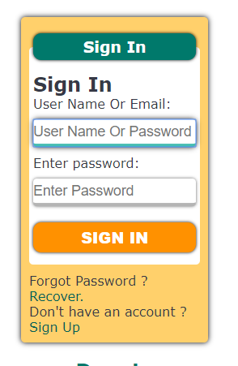

Figure 2: Chrome Brower

Paragraph of Home page: In Chrome, Paragraph of a news event came out of the area where it was in position in Firefox.

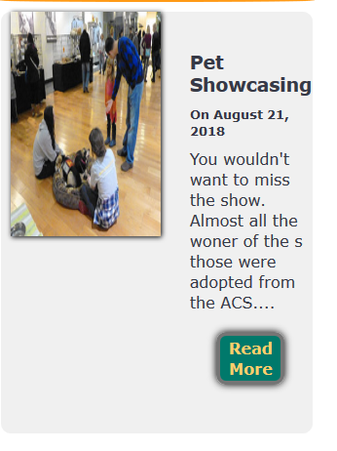

Figure 3:Firefox View

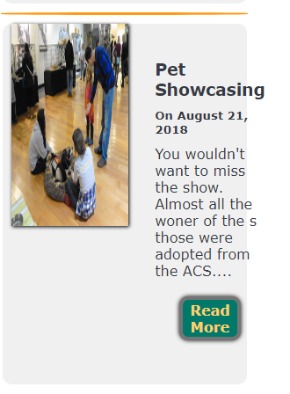

Figure 4: Chrome View

CSS file have to be fixed to position the paragraph in the area.

**Responsive View of Fund Raising Page:** In Mozilla Responsive page works fine. But in Chrome Responsive view isn’t working.

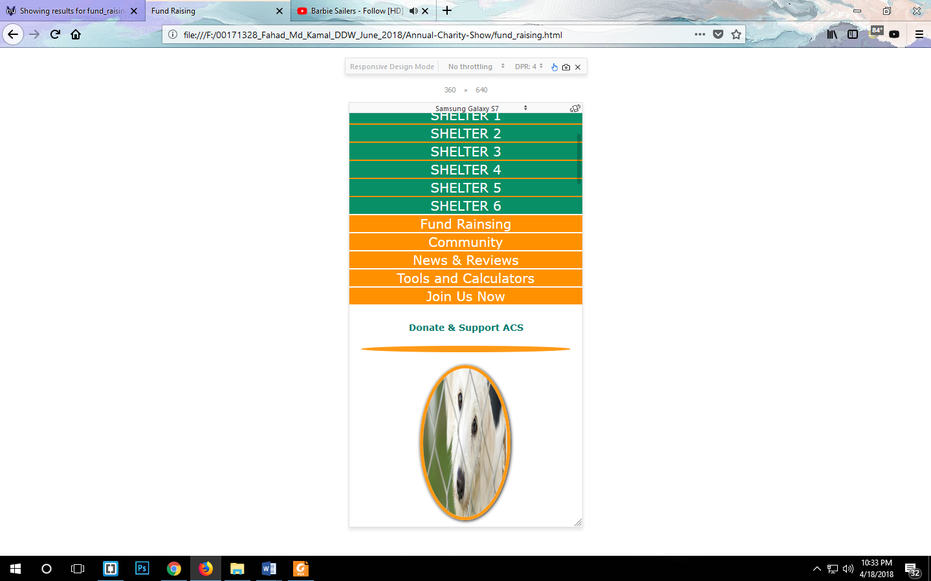

Figure 5: Firefox View

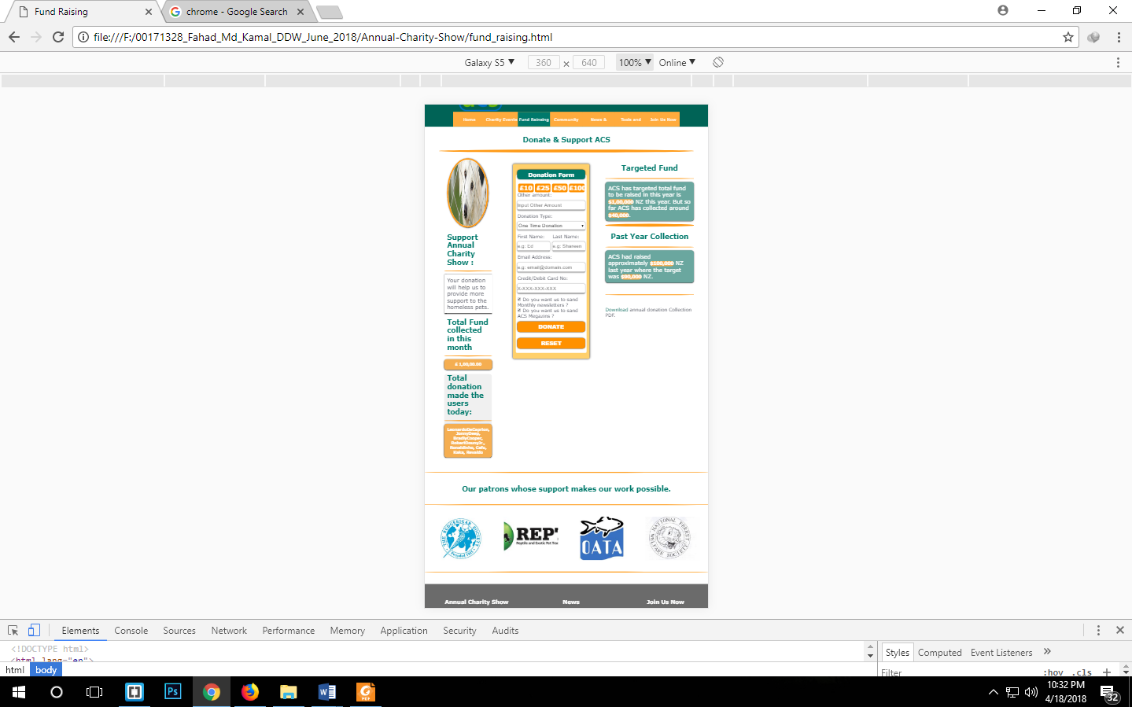

Figure 6: Chrome view

No problem is found in CSS property to change since w3c is not showing error for either html and CSS file. The fault is ambiguous until now.

The last difference is in the Join Us Now page:

In Mozilla the Map Image show smaller than the one shows in Chrome browser.

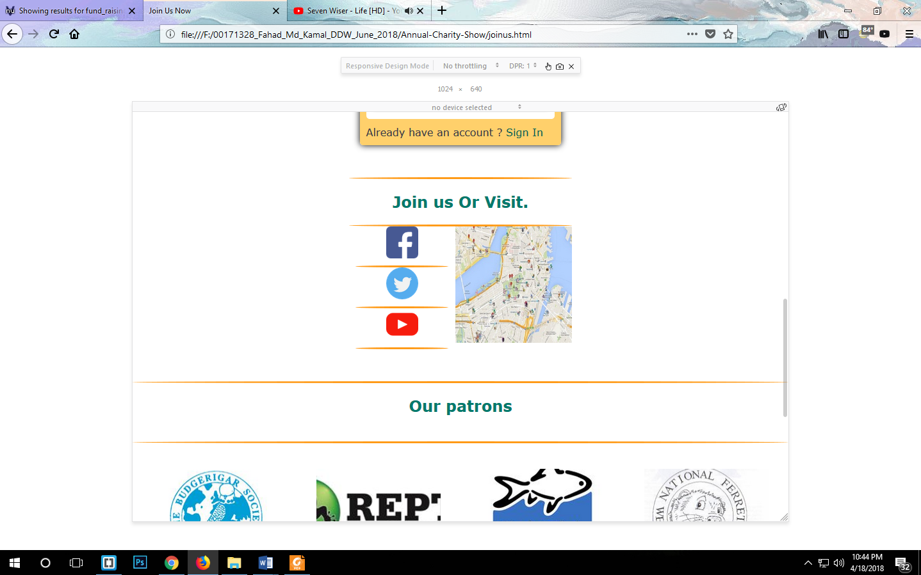

Figure 7: Firefox View

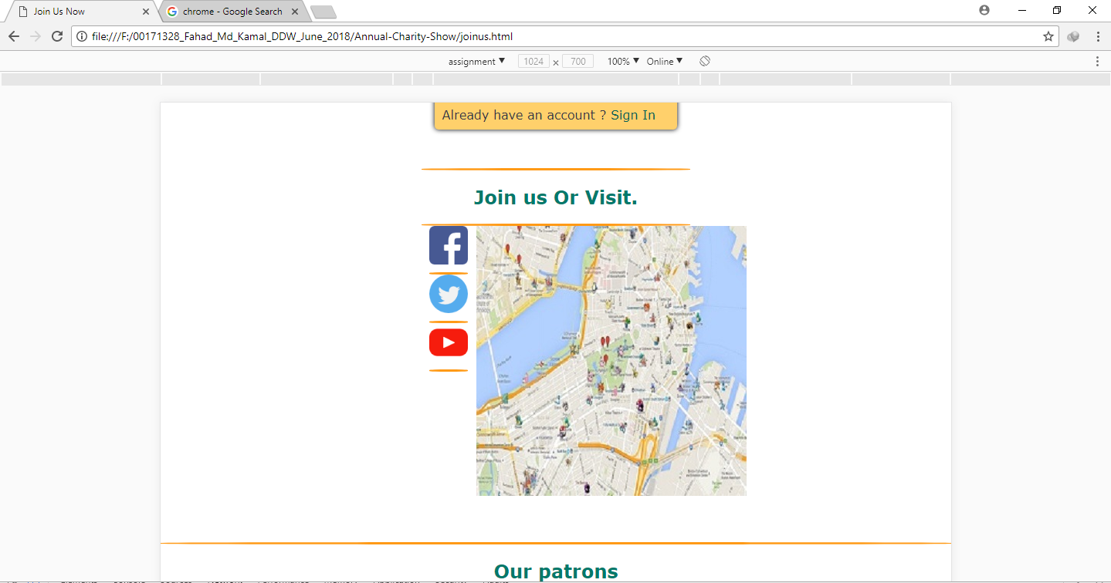

Figure 8: Chrome View

Here CSS file will have to be edited to give the proper height and width of the image.

**Task 4**

**Critical Evaluation**

**Advantages and Disadvantages of various types of multimedia file formats.**

**Image:**

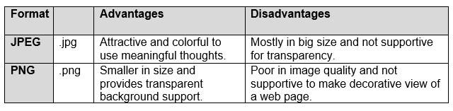

**Video:**

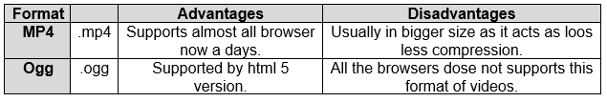

**Audio:**

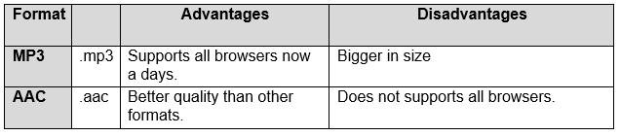

**Advantages and disadvantages of multimedia element in relation to contexts:**

There are several ways to make a website attractive or disaster based on multimedia items use. Several types of multimedia such as Image, Video, Audio and PDF files are available. Here the advantages and disadvantages are given for using multimedia items.

|  |  |
| --- | --- |
| **Advantages** | **Disadvantages** |
| Attractive media will help to make the content more interesting. | In appropriate content could discourage users for the real issue. |
| Interesting media would attract more visitors to visit the website. | Less interesting media would fail to attract visitors to visit the site. |
| Proper use of media elements would make the site fast and attractive. | Too much use of media would make the website load slowly. |
| Media items are used to make the handicap are less expert people use website more efficiently. | In proper use of media item would make the users irritated which would make the users to leave the site. |

**Advantages of developed website:**

* Less media elements were used in order to load faster the website.
* Used media items were resized to web version to reduce size.
* The web page has navigation menu in top to navigate the user to all the pages.
* Users can get information about various issues from the site.
* ACS can raise funds as donation through the website.
* Visitors can comment or rate by logging in to the site.
* Users can join ACS through social media or by visiting ACS.
* Users can download the financial report from the donation page.
* They can watch pet’s news from the pet news TV of News and Reviews page.
* Users can get information of events from the charity events page and join the events.
* They can request for monthly newsletters from ACS by completing the Sign Up form in Join Us Now page.

**Disadvantages:**

* The website is not much informative as it’s a demo type web page of the real web page.
* All the web pages aren’t responsive to use in mobile phone.
* The was not developed to use be useable for the disabled people.

**Suggestions for improvements:**

* The website is now without JavaScript, PHP, or Bootstrap which are used to make the website more attractive and real content handling.
* Home page’s big image would be used as slide show for several images by using JS.
* More media elements should be used to make it more informative.

**Further development:**

* Server site languages like PHP will be used to make the site dynamic.
* JS will used to make the site alive and attractive on the browsers.
* All the pages will be made mobile friendly by utilizing media query attribute on CSS.
* The site will be developed as mobile and disabled people friendly.
* More relevant content and media will be used to make the site meaningful.

Making mobile website with CSS3:

**Advantages:**

* In CSS3 device capability is checked instead of device type.
* CSS3 is of simple attributes.
* CSS3 compares width and height of the viewport.
* Devices height, width
* Landscape or portrait mode.
* Resolution.

**Disadvantages:**

* There are two rules (max-width) and (min-width) to make responsive website. Which is really confusing to select for the beginners like me.
* Responsive codes sometimes have to type for several times which is tedious.
* If the rules are not mate accordingly the website would fail to work.

**Conclusion:**

The report is made with the developments of ACS website. This report shows how the website will appear on mobile phone and desktop version when final site will be developed error free. Here the suggestion and further developments are also highlighted in order to show how the final website would look and function in future when the client would provide actual contents at a later point.